## PCP.jpg

**Bulmer Parish Council**

**Neighbourhood Plan: Residents’ Survey**

**December 2023**

***Report prepared by:***

***Pickersgill Consultancy and Planning Ltd (PCP)***

***Woodlands***

***Church Lane***

***Welburn***

***York***

***YO60 7EG***

Table of Contents Page Number

1. Introduction 4

2. Methodology 4

3. Executive Summary …………………..6

4. Detailed Findings 9

*4.1 Response Rate………………………………………………………………………9*

*4.2 Profile of Respondents……………………………………………………………10*

*4.2.1 Age………………………………………………………………….……..…10*

*4.2.1 Gender………………………………………………………………….……10*

*4.2.3 Number of Adults in Household..…………………………………….…....11*

*4.2.4 Presence of Children under Age of 18 in Household………….………..12*

*4.2.5 Time in Parish ……………………………………………………….……12*

*4.2.6 Housing Tenure ……………………………………………………….……14*

*4.2.7 Vehicle Ownership…………………………………………………….……..14*

*4.2.8 Use of Public Transport………………………………………………….….15*

*4.2.9 Use of Bus Service if Frequency Increased..………………………….….16*

*4.3 Attitudes to Living in Bulmer Parish.…………………………………...………..17*

*4.3.1 Spontaneous Likes and Dislikes…………..…………………………….17*

*4.3.2 Prompted Ratings of Aspects of living in Bulmer Parish……………...19*

*4.3.3 Desired Changes, Additions or Improvements to Facilities.……...….20*

*4.3.3.1 Spontaneous Comments……………………………………….20*

*4.3.3.2 Prompted Reactions…………………………………………….21*

*4.4 Attitudes to Housing Development in the Parish…………………...…………..22*

*4.4.1 Desired Level of Housing Development………………...……………...22*

*4.4.2 Type of Home Appropriate for any Development in the Parish...……24*

*4.4.3 Style of Home Appropriate for any Development in the Parish...……25*

*4.4.4 Desired Location for any Development in the Parish…………....……26*

*4.4.5 Importance of Features if Housing Development were to take place.27*

*4.4.6 Perceived Benefits and Concerns towards future Development…….29*

*4.4.6.1 Spontaneous Comments……………………………………….29*

*4.4.6.2 Prompted Reactions…………………………………………….30*

*4.5 Barriers to living in Bulmer Parish…………….………………………………….31*

*4.6 Views on Affordable Housing …………………….……………………………...32*

*4.7 Tenants’ Desire to Buy a House in Bulmer………….………………………….33*

*4.8 Sources of Community News and Information ..…………………………….…33*

*4.9 Importance of Features to the Character of Bulmer Parish…………...………34*

*4.10 Final Comments…………………………………………….……………………..35*

*Appendix One – Respondent Questionnaire………………………………………………….…36*

*Appendix Two – Invitation Letter……………………………………………………………….…47*

# Introduction

The Working Group of Bulmer Parish Council commissioned Pickersgill Consultancy & Planning Ltd (PCP) to conduct a survey of residents of the Parish to aid the development of a Neighbourhood Plan.

This report summarises the results from the research and the main conclusions drawn.

# Methodology

A questionnaire was drawn up by members of the Working Group in consultation with PCP. The final version agreed is shown as Appendix One.

A letter from Bulmer Parish Council was distributed by members of the Working Group to all households in the Parish over the weekend of 29th - 30th October. The letter, shown as Appendix Two, explained the purpose of the research and the appointment of PCP as an independent research agency to ensure that all responses to the survey were treated in strict confidence. The letter included a link to the survey and residents over the age of 18 were invited to visit this link and to complete the questionnaire online before the deadline of 30th November. All adult residents within a household were encouraged to take part, to allow for the possibility that different members of a household may have different views on some of the topics raised. Unless otherwise, all percentages in the report are based on the 69 individuals completing and submitting a questionnaire.

A reminder letter was delivered to all households over the weekend of 18th – 19th November.

It was important to ensure that all 84 households in the Parish received a copy of the letter so that no-one could say that they had not had an opportunity to contribute their views. The list of addresses of all households in the village was drawn up by the Working Group.

A PCP FREEPHONE number was also provided in the letter:

* To help residents with any queries;

* To provide an option for them to complete the survey over the phone;

* To allow them to request a hard copy of the questionnaire to be mailed to them for self- completion and return by pre-paid post.

Each address was assigned a random 3-digit number between 100 and 999. This number was included in the invitation letter and was required to start the survey. This ensured both anonymity of responses and also that only residents of the Parish could participate. It also allowed the number of responses per household to be tracked and so ensure that an excessive number of responses were not submitted from the same household. The numbers were allocated randomly so that a resident would not know which had been allocated to another household and so would not have been able to submit a response on their behalf.

# Executive Summary

3.1 A good response to the survey was achieved, with 64% of all households in the Parish completing at least one questionnaire. This allows us to state with reasonable confidence that the results can be assumed to be representative of all households in the Parish.

3.2 Rather more disappointingly, however, the majority of households completed only one questionnaire. It is likely that those household members not completing a questionnaire believed that their views had been captured by the member who did, but this cannot of course be assumed.

3.3 The population of the Parish is rather elderly and almost three quarters of the respondents were aged 55 or over. Only 7% were aged under the age of 35. 78% of respondents had no children under 18 living with them on a permanent basis.

3.4 One quarter of respondents lived alone and most of the remainder lived with one other adult. The average size of household was 1.9 adults and 0.2 children.

3.5 Two thirds of the respondents were home owners. 29% rented their property.

3.6 All households taking part in the survey owned at least one vehicle. Probably reflecting the availability of a vehicle to them, respondents’ use of public transport was relatively limited. A more frequent bus service through the village would appear unlikely to increase greatly the frequency of use of this service. Only 10% of respondents stated that they would use the bus service ‘much more’ if it ran more frequently.

3.7 The majority of respondents were long-term residents of the Parish, with 61% having lived there for at least 10 years. Very few have any definite intention to move from the Parish in the next 10 years. It is clear that the great majority of residents like the Parish the way it is and have very little appetite for more than minor changes.

3.8 The three aspects of living in Bulmer most likely to be picked out spontaneously for positive mention were the friendly community feel, its quietness and its location surrounded by countryside. All these aspects were mentioned spontaneously by around half of the respondents.

3.9 The only dislikes about living in the Parish mentioned spontaneously by more than 10% of respondents were the lack of a village shop and the speeding vehicles through the village. Both these aspects were mentioned by 20% of respondents.

3.10 When prompted with a list of aspects of living in Bulmer Parish and asked to rate each on a scale from ‘very good’ to ‘very poor’, satisfaction was very high. Three quarters or more of respondents rated as very good the attractiveness of the local countryside (96%), the amount of green space (86%), the size of the village (80%), the wildlife (77%) and the availability of local walks (75%).

3.11 The only aspects attracting significant numbers of ratings of ‘quite poor’ or ‘very poor’ were the facilities for children and those for adults. Of the 15 respondents with children in the household, only 7% rated the facilities for children as ‘very good’ and 27% as ‘quite good’, but 33% rated them ‘quite poor’ and another 33% as ‘very poor’. If the Parish is hoping to attract more families with children into the area, facilities would seem to be in need of improvement.

3.12 When respondents were presented with a list of possible changes, additions or improvements and asked which they would see as priority items, Speed Control Measures (rated a priority item by 51% of respondents), improved mobile phone connection (42%), maintenance and signage of footpaths (38%) and reduction in dog fouling (35%) were most likely to be selected.

3.13 Respondents generally favoured at most only limited development in the Parish. No respondent preferred more than a maximum of 20 additional houses. Indeed, a quarter (26%) preferred no additional houses at all and 77% wanted none or up to 10 at most.

3.14 Over two thirds of those respondents prepared to consider at least some housing development would see either two bedroom starter homes or three bedroom family homes as appropriate. Single storey homes or bungalows would be seen as appropriate by almost half of them.

3.15 There was almost universal rejection of new homes not conforming to the style of the conservation area, but either conservation of existing buildings or new builds conforming to the style of the conservation would be approved by the great majority of those willing to consider some development.

3.16 The preferred site for any development would be either in-fill development where the opportunity allowed (73% favoured this option) or on the eastern edge of the village (53%). Development on the western edge or elsewhere was less favoured.

3.17 Respondents had strong views on the importance of many features if housing development were to take place. Around three quarters or more of all respondents rated as ‘very important’ sustainable drainage systems (84%), appropriate design / architecture (78%), adequate off-street parking (75%) and adequate access (e.g. no parking on sharp corners or narrow lanes) (74%). No more than 3% of respondents saw any of these four features as ‘not very’ or ‘not at all’ important.

3.18 The only features for any housing development seen as ‘not very’ or ‘not at all’ important by the majority of respondents were Commercial Development (78% felt this was ‘not very’ or ‘not at all’ important), Leisure Facilities (66%) and Allotments (64%).

3.19 Respondents expressed great concerns about many aspects of housing development in the Parish. Indeed, more than half of all respondents expressed ‘major’ concern with all but one of nine prompted statements provided to them. Aspects of greatest concern were excessive parking on roads (75% saw this as of major concern), loss of character, appearance or feel (74%) and speeding vehicles (70%).

3.20 Over two fifths of respondents (41%) felt that there would be no benefits to housing development at all. The two benefits most likely to be mentioned (but by only around one fifth of all respondents) were that development would bring children to the village through affordable family homes and that it would broaden the spread of ages in the village.

3.21 29% of respondents claimed to know someone who would like to live in the Parish. Reasons why respondents felt that these people were unable to live in the Parish mostly centred on high house prices, high rental costs or the lack of Affordable Housing.

3.22 A strong majority (64%) favoured the allocation of some sites for Affordable Housing, but 26% strongly disagreed. As might be expected, most of those disagreeing were those preferring that there should be no development in the Parish.

3.23 12 of the 20 tenants completing the survey stated that they would like to buy a house in Bulmer. All these tenants stated that the high prices of houses in Bulmer Parish were preventing them from doing so.

3.24 The village newsletter and word of mouth / grapevine were both rated ‘very useful’ as sources of community news and information by over 50% of those completing the survey and as ‘quite’ or ‘very’ useful by over 85%. Parish noticeboards were seen as ‘quite’ or ‘very’ useful by 87% of respondents and the Parish website and local newspapers by around half the respondents. Facebook, Twitter / X and local radio were less likely to be seen as useful.

3.25 An overwhelming majority (80% or more) of respondents felt that the landscape generally, trees / groups of trees, woodland, hedgerows, views and wildlife were ‘very important’ to the character of Bulmer Parish. Virtually all those who did not feel these features were ‘very important’ felt they were ‘quite important’.

# Detailed Findings

# 4.1 Response Rate

A total of 69 responses were received from 54 different households. Thus 64% of the 84 households in the Parish completed at least one copy of the questionnaire. This can be seen as an encouraging response rate, allowing the views expressed to be put forward with reasonable confidence as representing the views of all households in the Parish.

Based on the answers given to a question in the survey, the 54 households completing a questionnaire contained 102 adult members. This implies that only 68% (69 out of 102) adults in these households completed a questionnaire and this is a rather more disappointing finding. It is likely that many of the households submitting only one response did so on the basis that their fellow resident(s) felt the same way, but this cannot of course be assumed.

Assuming the same number of adults per household in households not completing the survey, it can be estimated that there are 159 adults living in the Parish. In that case, the response rate for individuals would be estimated at 43%. However, this is likely to be an underestimate as the calculation makes no allowance for empty houses.

45 households and 58 individuals completed the survey online. 8 households and 10 individuals completed it on paper and 1 household, 1 individual completed it over the telephone.

**4.2 Profile of Respondents**

**4.2.1 Age**

The chart below shows the age distribution of respondents. Only 1% chose to answer ‘prefer not to say’ so a clear picture of the age profile can be seen. Almost three quarters of the respondents were aged 55 or over, reflecting the relatively elderly population of the Parish. Only 7% were aged under 35.

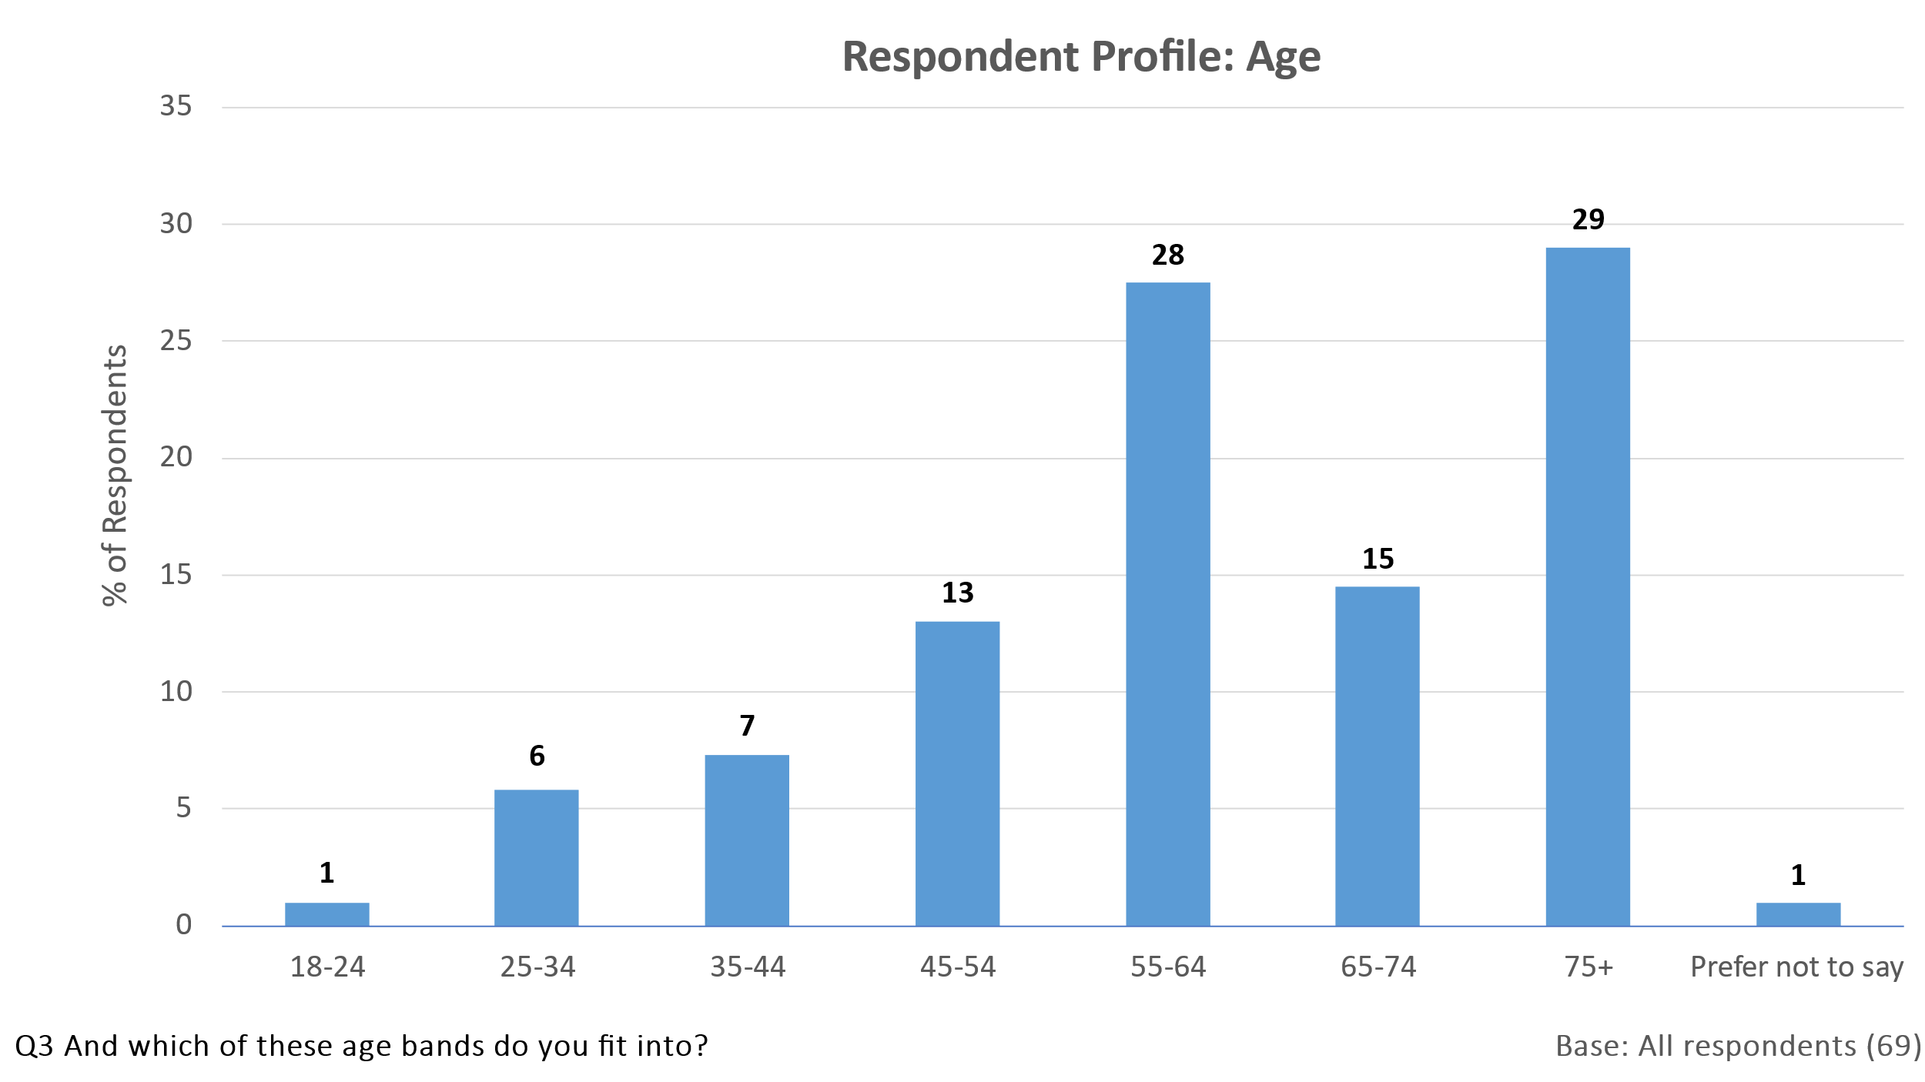

**4.2.2 Gender**

Slightly more responses were received from females than from males. The majority of households containing only one adult (69%) were occupied by a female. Amongst households with two or more adult members, half the responses were from males and half from females.

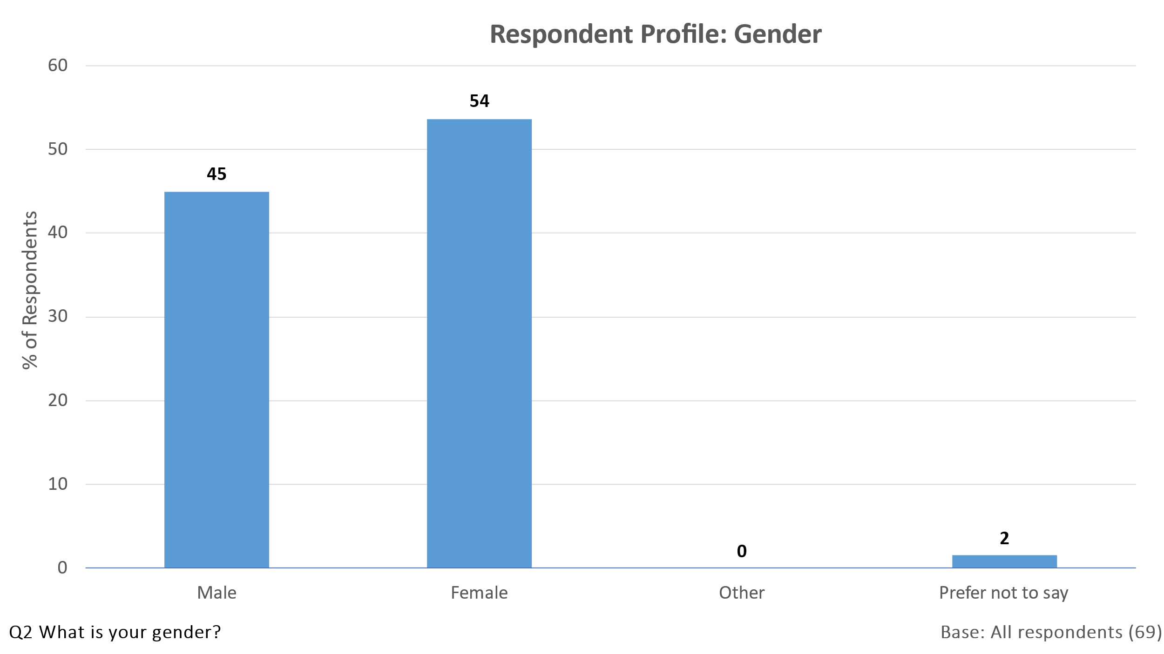

**4.2.3 Number of Adults in Household**

One quarter of respondents lived on their own and over half lived with one other adult. The average number of adults per household was 1.9.

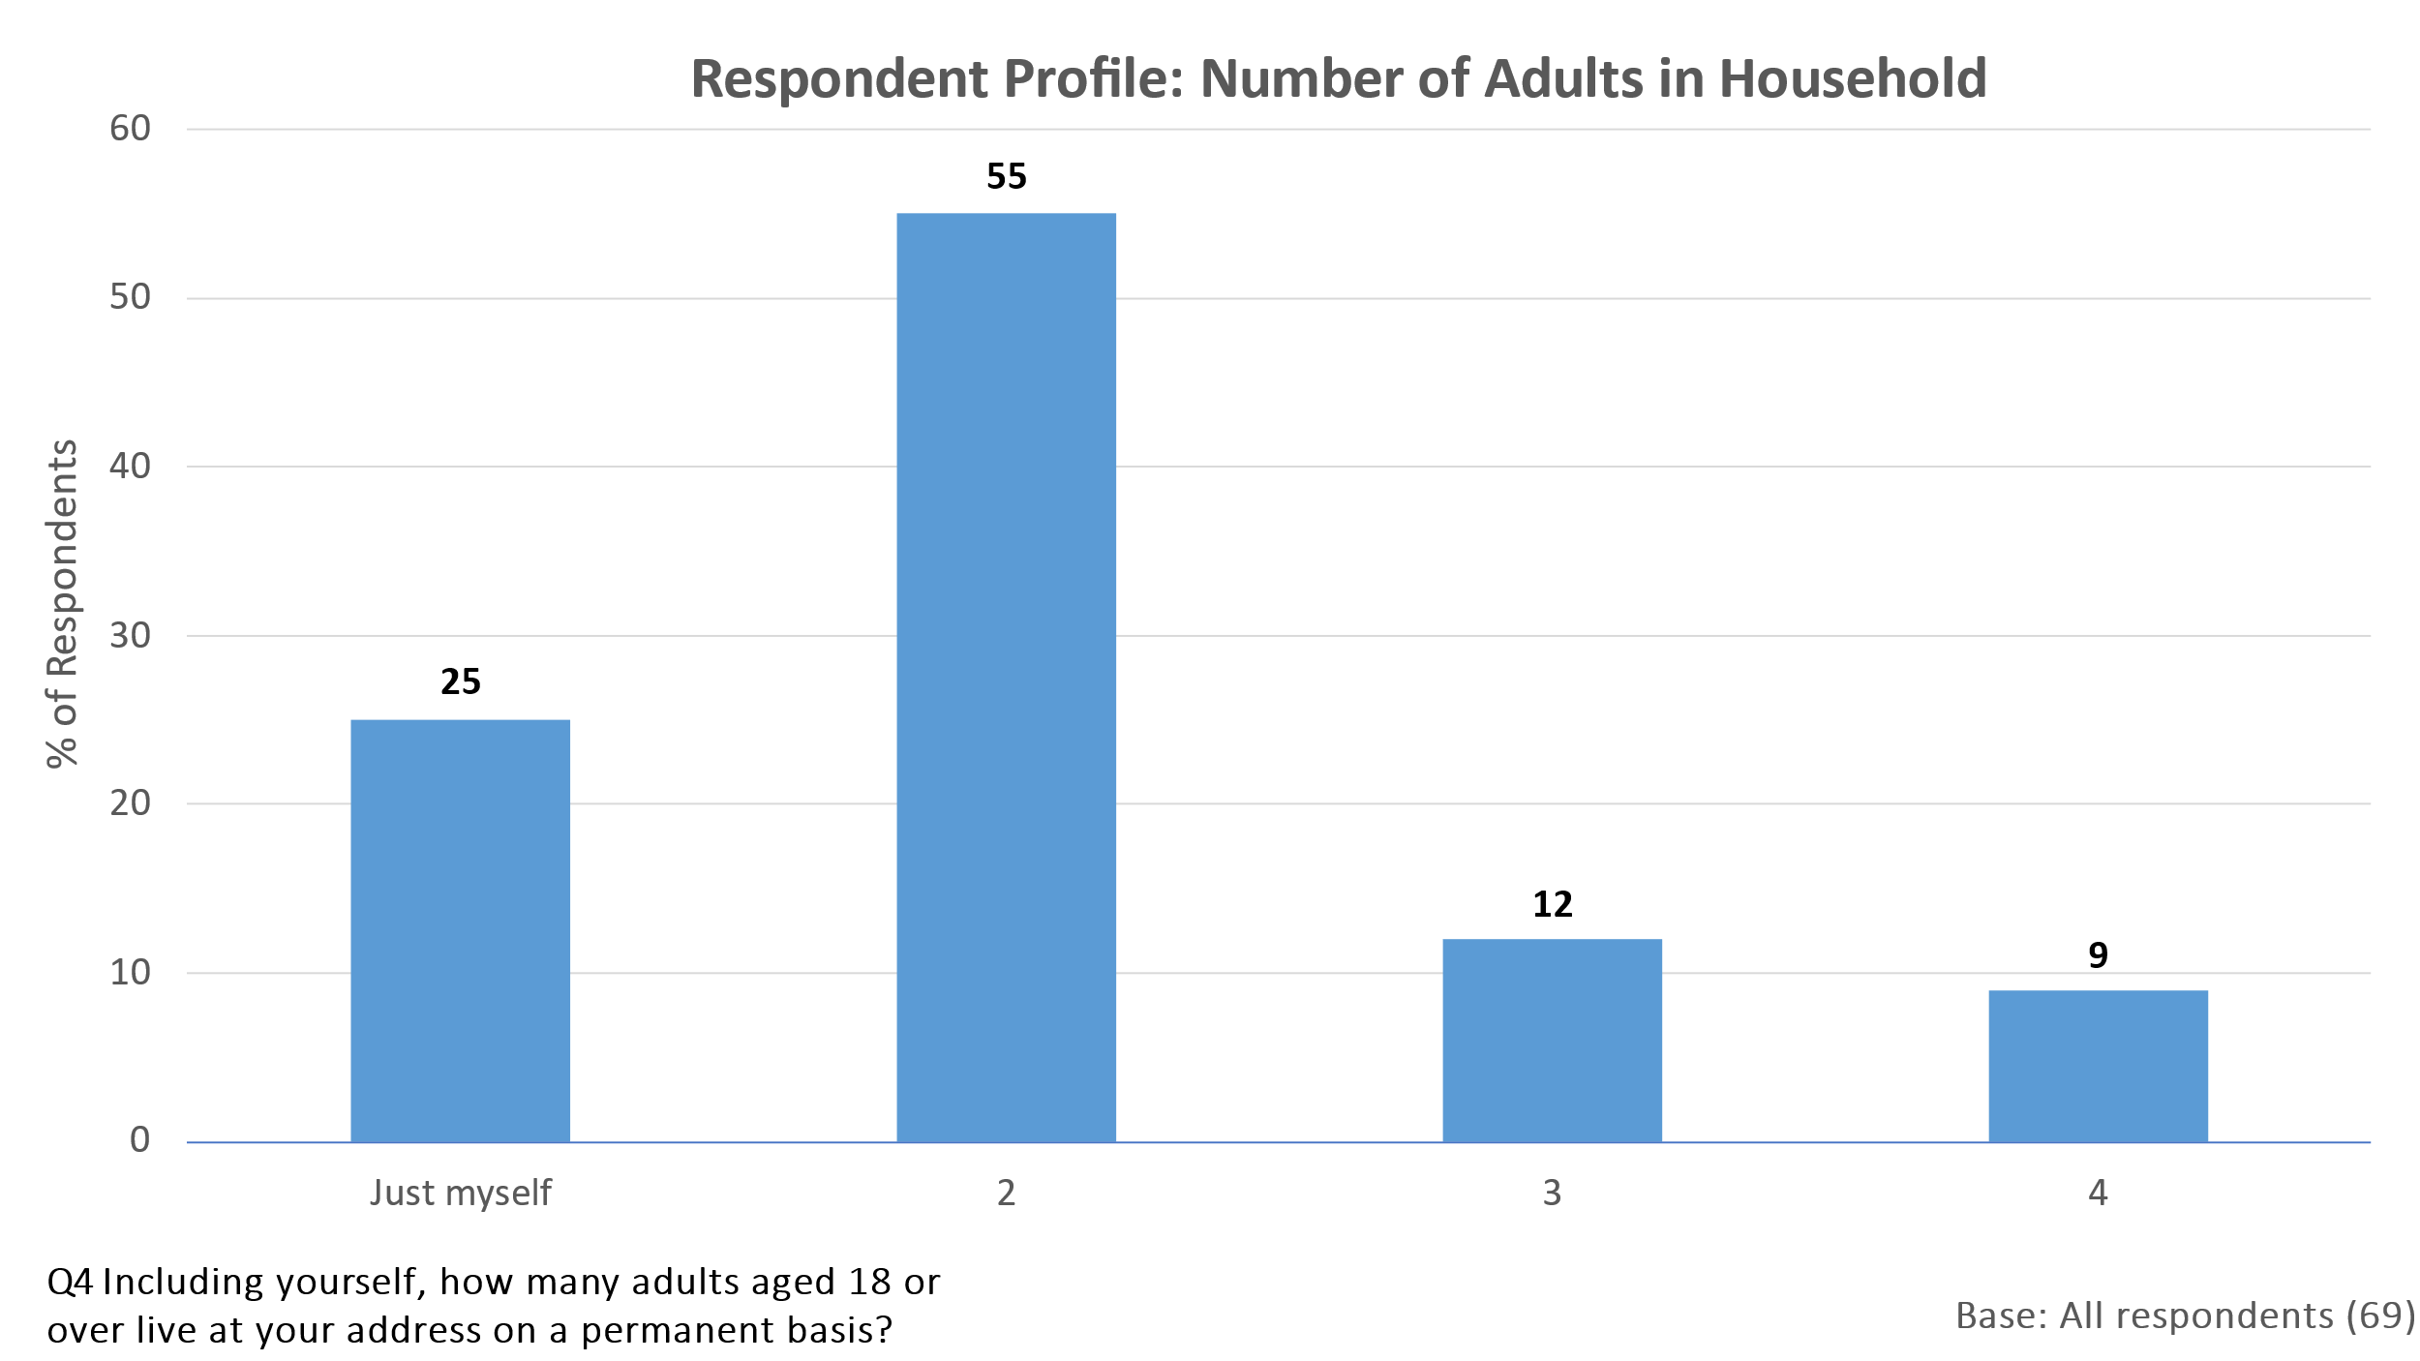

**4.2.4 Presence of Children under Age of 18 in Household**

Almost four fifths of respondents had no children aged under 18 living at the address on a permanent basis. 19% had one child under the age of 18 living with them and 3% had two. No respondents had more than two children living with them.

The average number of children per household was therefore 0.2 and the average number of people (adults and children) was 2.1.

The chart below shows the percentage of respondents with children of different ages living with them. 10% had a child aged 12-15 and 6% had one aged 4 and under.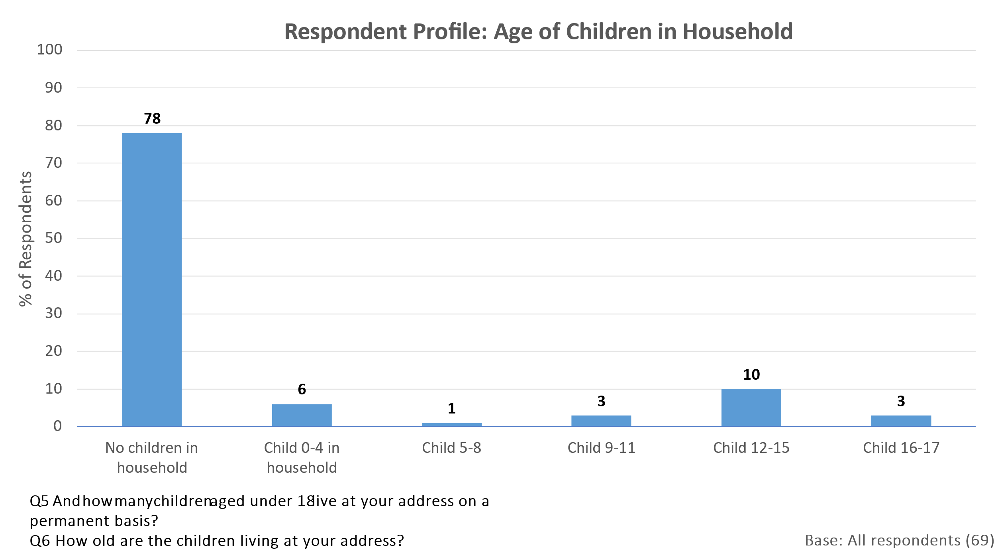

**4.2.5 Time in Parish**

The chart below shows that 61% of respondents have lived in the Parish for more than 10 years, so would be considered long-term residents. One third (32%) have lived in the Parish for five years or less.

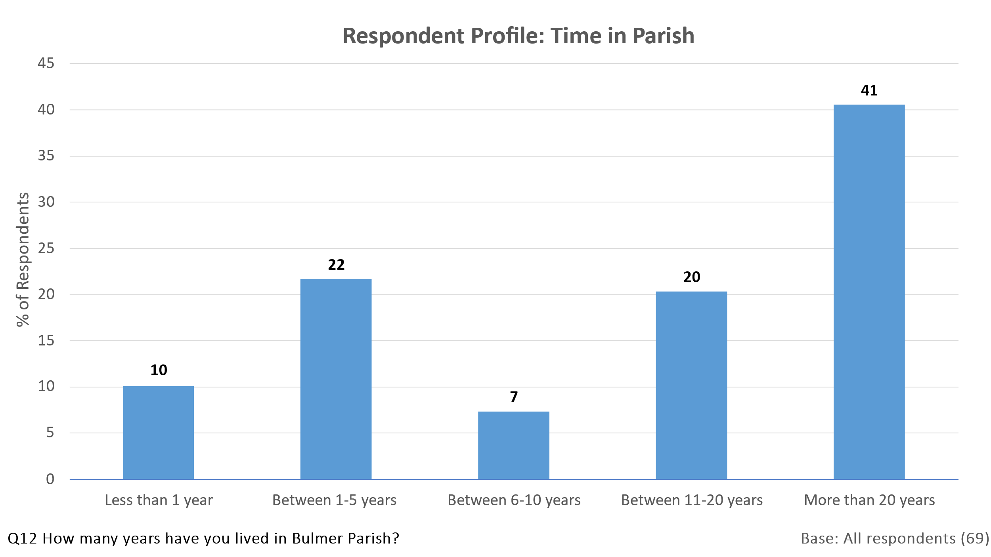

82% of respondents said they would be “quite likely” or “very likely” to remain in the Parish for at least the next 10 years and most of the remainder answered ‘Don’t know’. Only 5% stated that they were ‘not very’ or ‘not at all’ likely to remain.

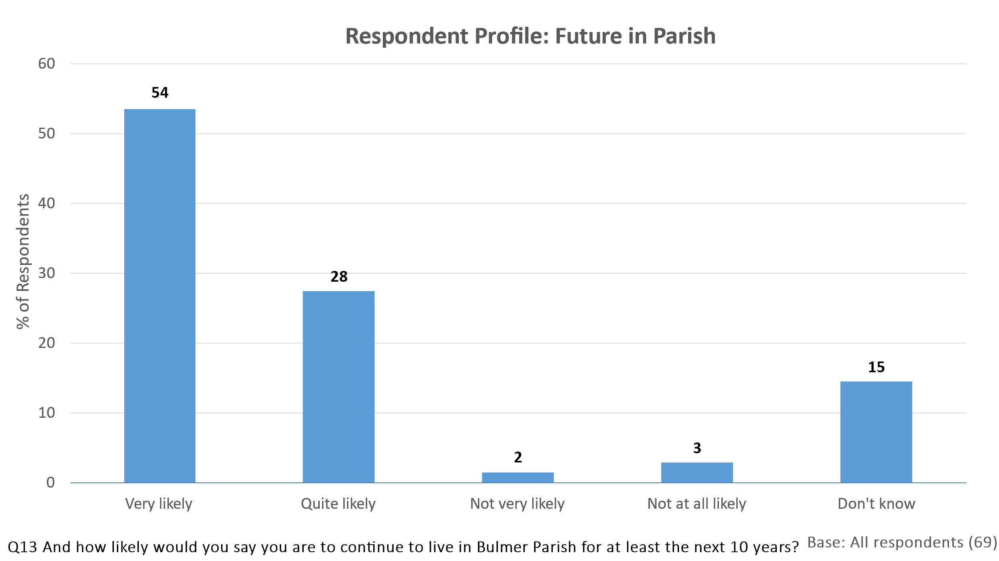

**4.2.6 Housing Tenure**

Around two-thirds of respondents own their home, with most of the remainder occupying as tenants. This is a higher level of tenant occupancy than for Welburn, where only 13% of those responding to the survey rented from a housing association or private landlord.

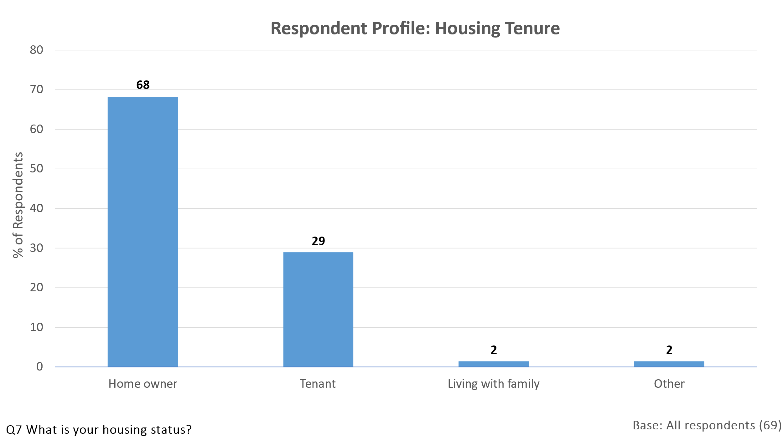

**4.2.7 Vehicle Ownership**

All respondents owned at least one vehicle and the majority owned two or more.

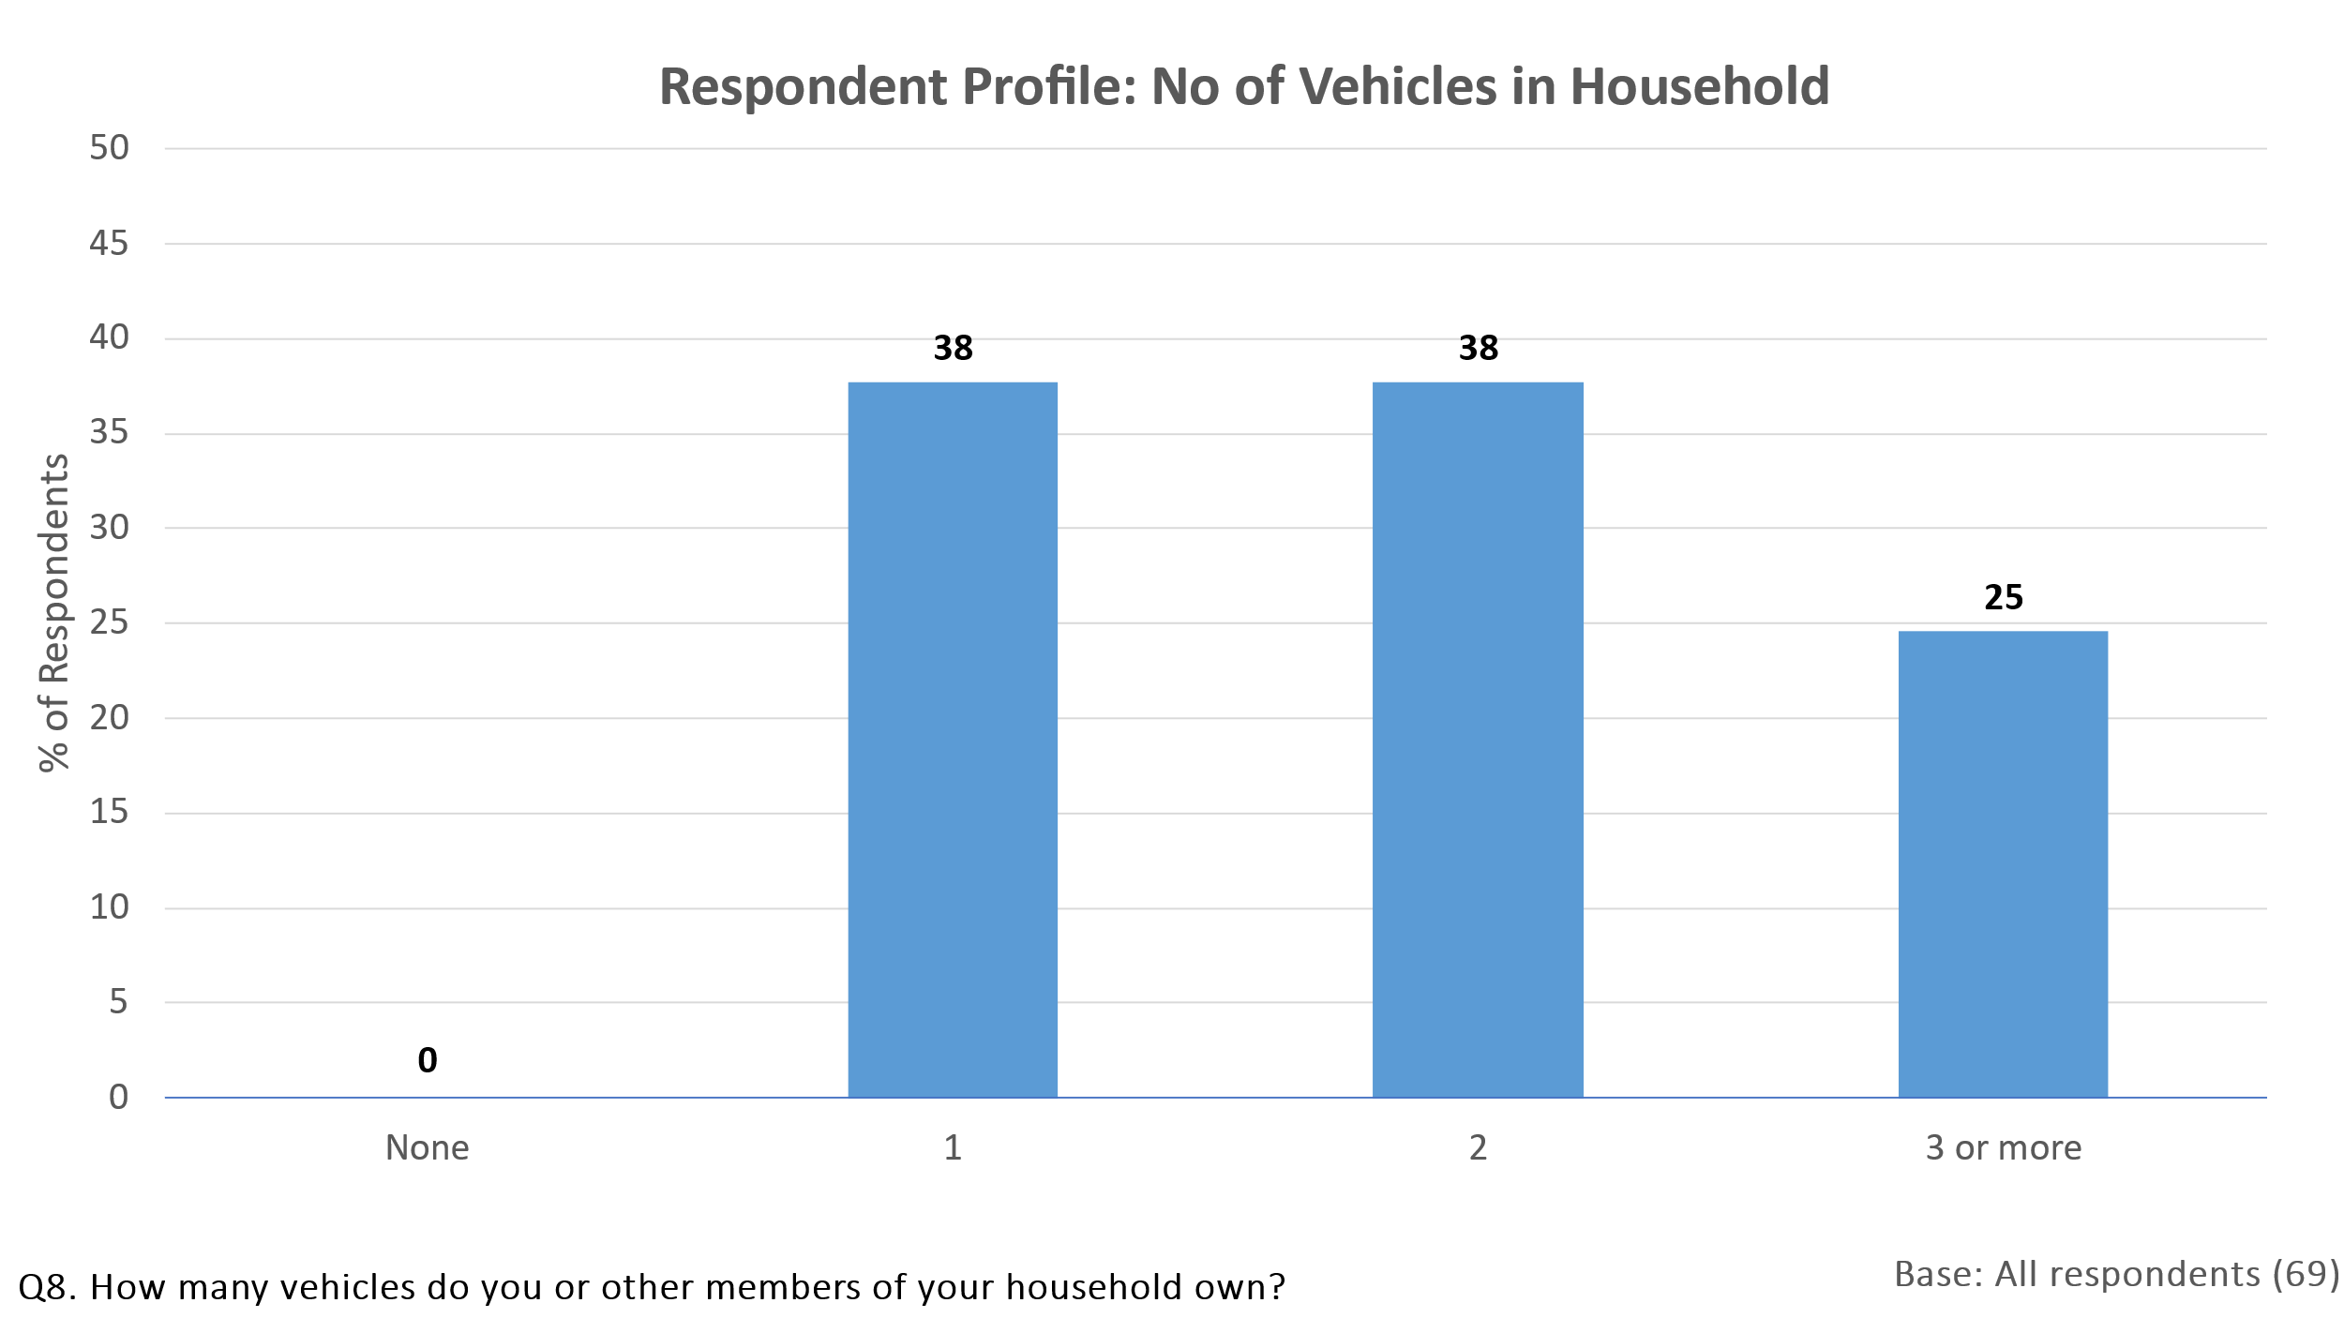

**4.2.8 Use of Public Transport**

Public transport is relatively little used by residents of Bulmer. 80% and 78% of respondents claimed to ‘rarely or never use’ the buses running through the village or the A64 Coastliner bus respectively. No respondents used the buses through the village more than once a month and only 3% used the Coastliner bus with that frequency.

Trains from Malton were slightly more likely to be used by respondents but again most of those doing so used them less than once a month. Three quarters of respondents (74%) ‘rarely or never’ used a taxi or mini cab.

Given the low level of usage of any of these forms of public transport, it is perhaps not surprising that all respondents owned at least one vehicle.

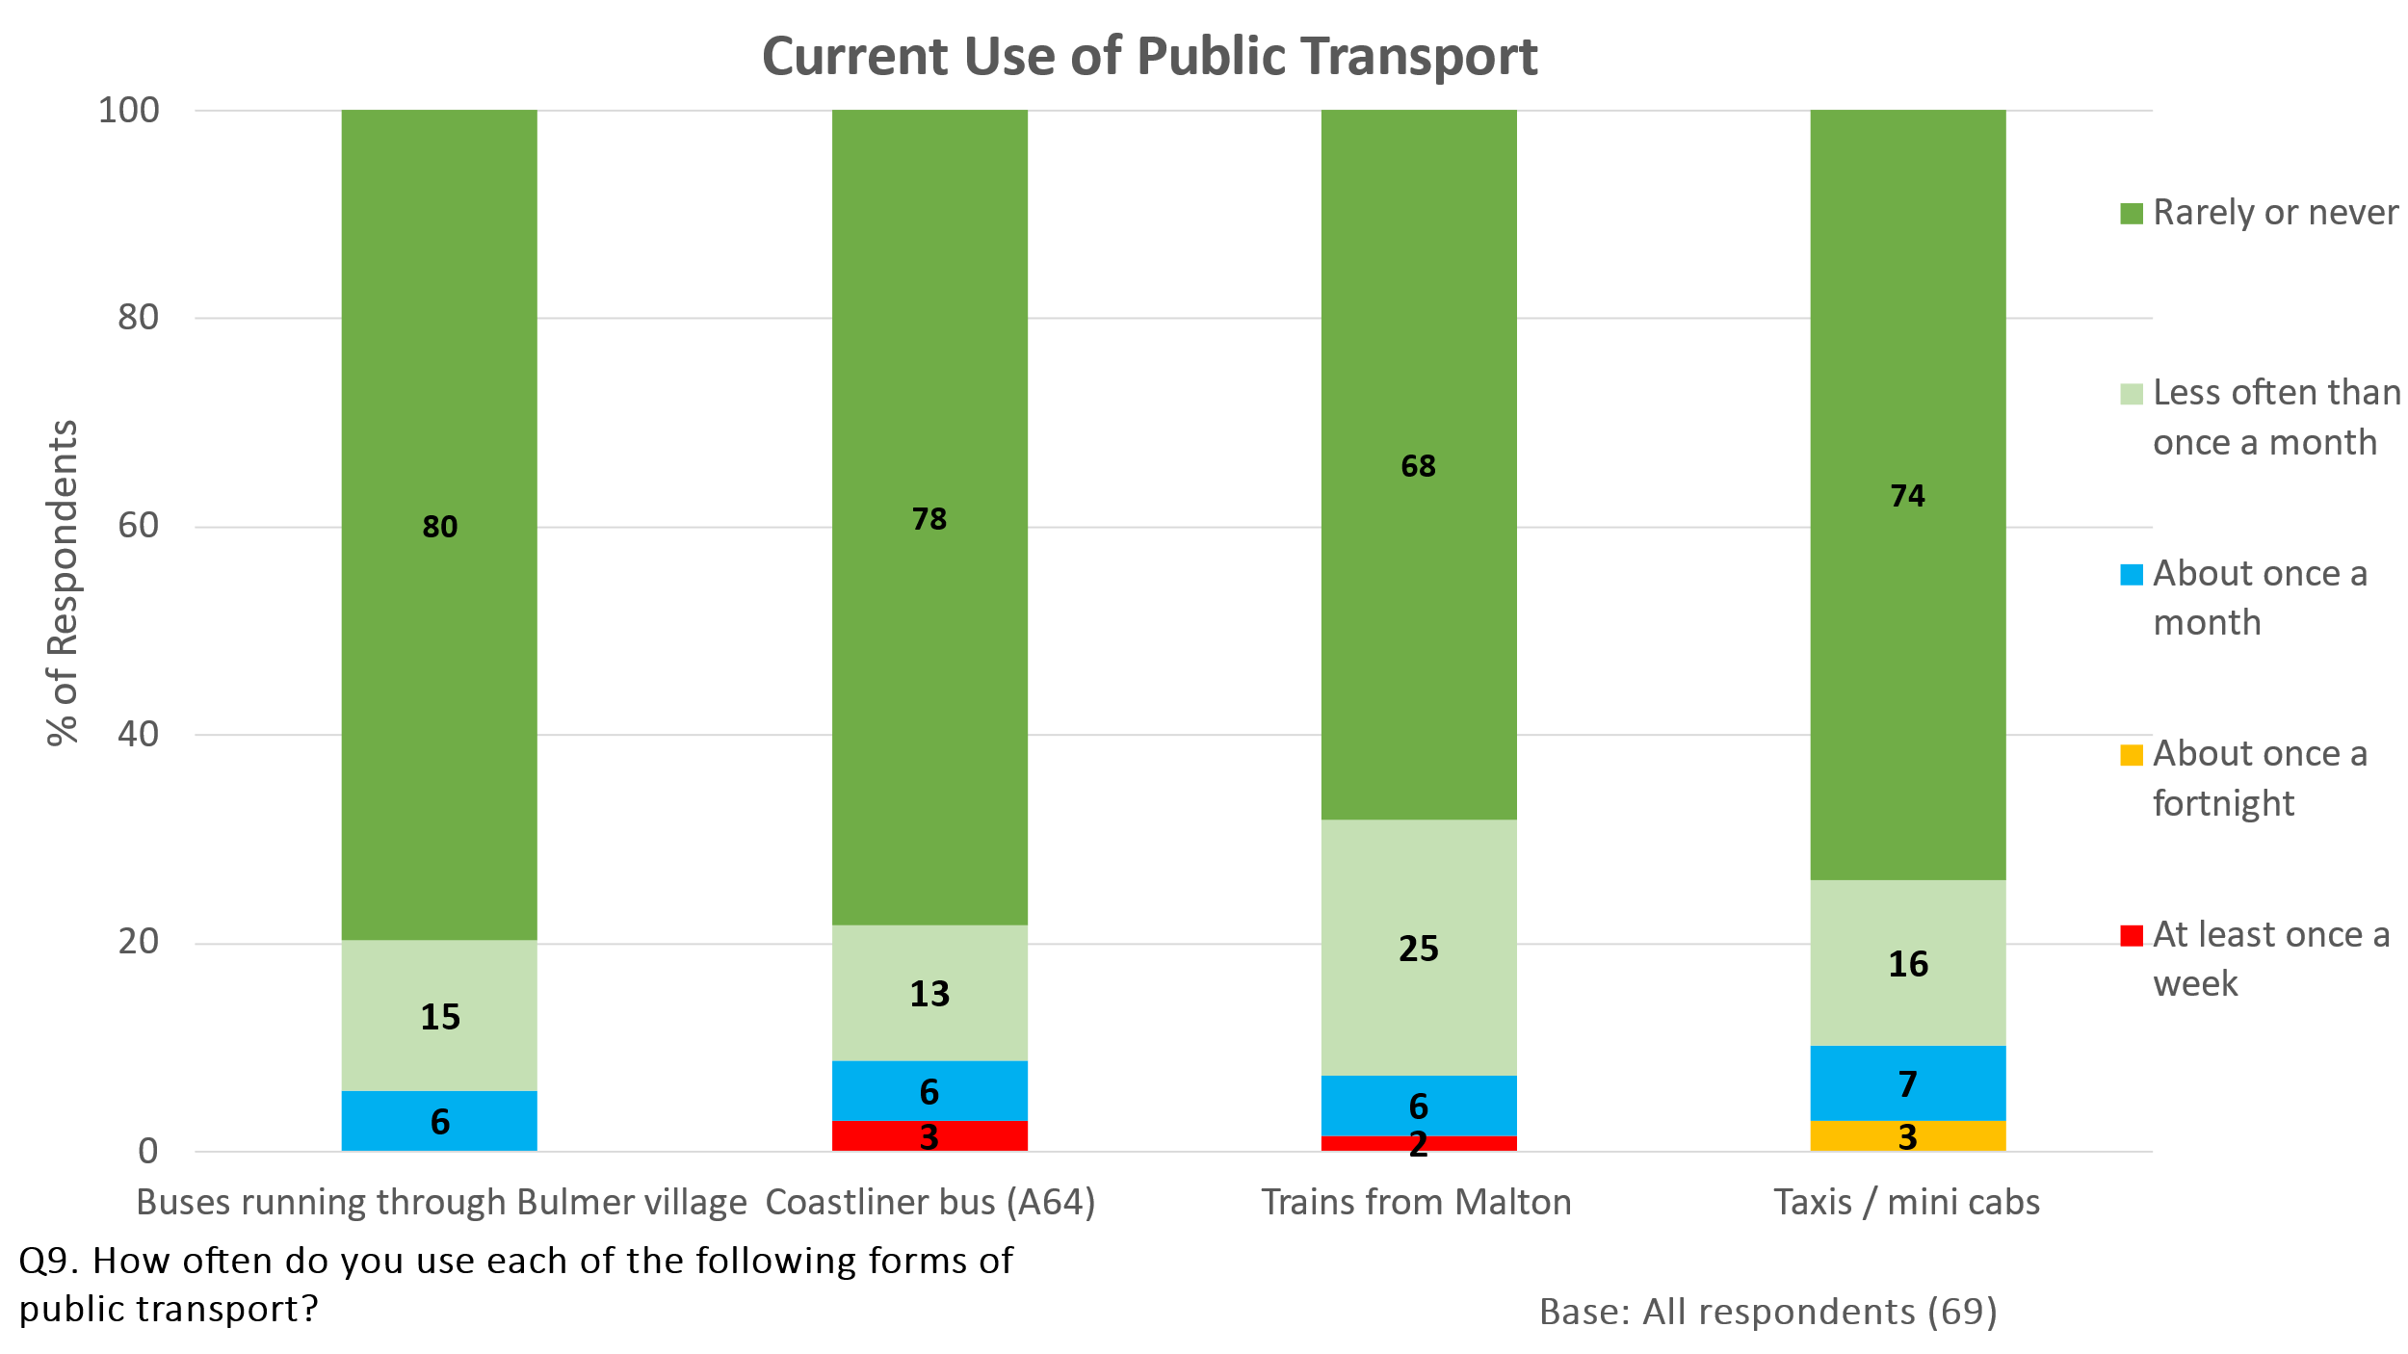

**4.2.9 Use of Bus Service if Frequency Increased**

The majority of respondents (71%) said either that an increase in the frequency of the bus service through the village would not increase their usage or that they did not know whether it would. Only 10% said they would use the service ‘much more’ in these circumstances.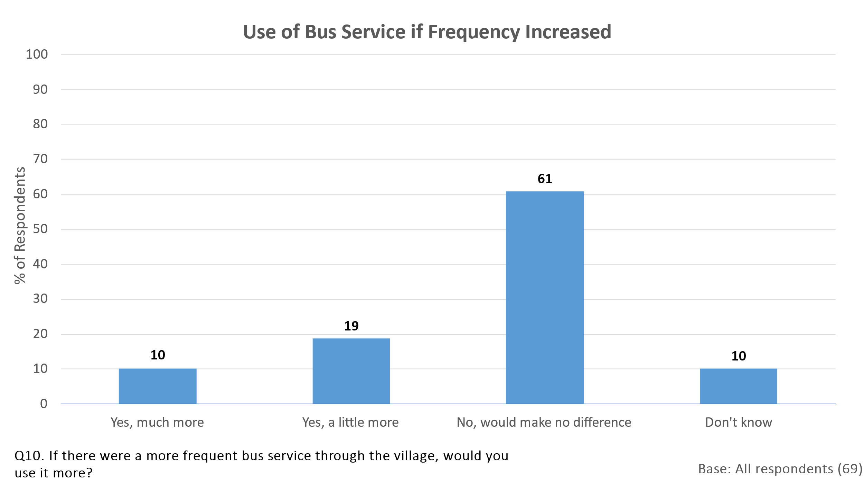

The 20 residents saying they would use the local bus service more if it ran more frequently were asked how frequently it would have to run before they used it more. Six said it would have to run every hour or eight times a day, three said every two hours, three said four times a day and two said once a day. Four said an evening service was more important and two asked for a frequent weekend service.

**4.3 Attitudes to Living in Bulmer Parish**

**4.3.1 Spontaneous Likes and Dislikes**

Respondents were asked separate unprompted questions about what they particularly liked and disliked about living in the Parish. The likes far outweighed the dislikes and it is clear that most residents are extremely happy with their choice of location.

The three aspects of living in the Parish most likely to be picked out for positive mention were the friendly community feel, its quietness and its location surrounded by countryside (all these aspects were mentioned by around half of the respondents, with a further 26% stating that Bulmer was an attractive place to live).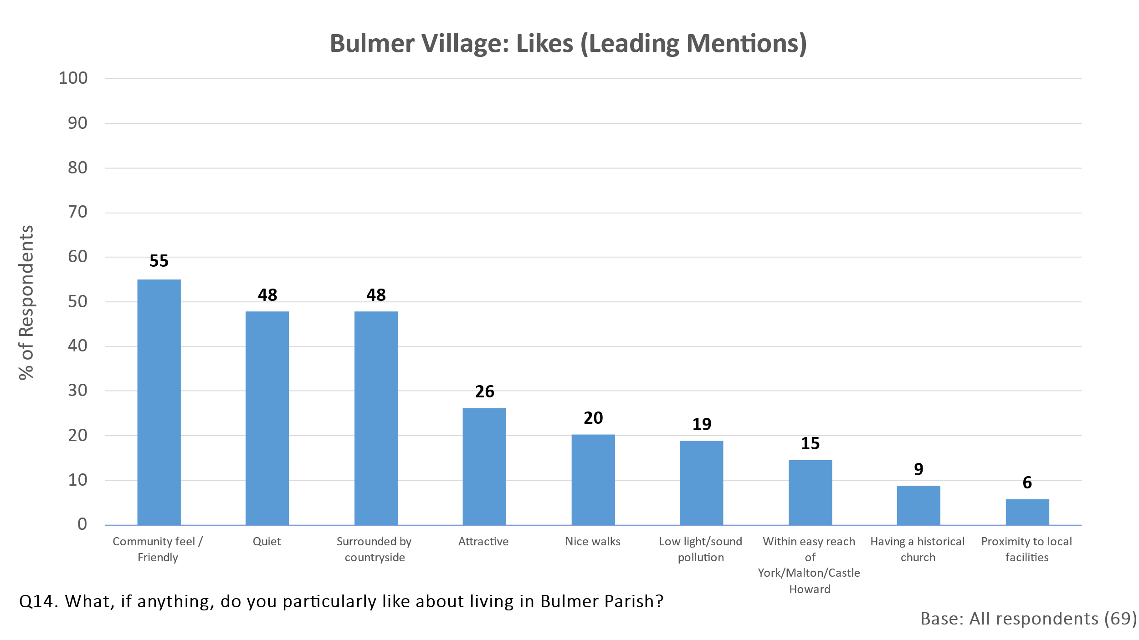

By contrast, 42% of respondents found nothing to dislike about living in the Parish. The only two dislikes mentioned by 10% or more of respondents were the lack of a village shop and the speeding traffic through the village; even these points were raised by only one fifth of all respondents. The lack of a pub was mentioned by 7% of respondents.

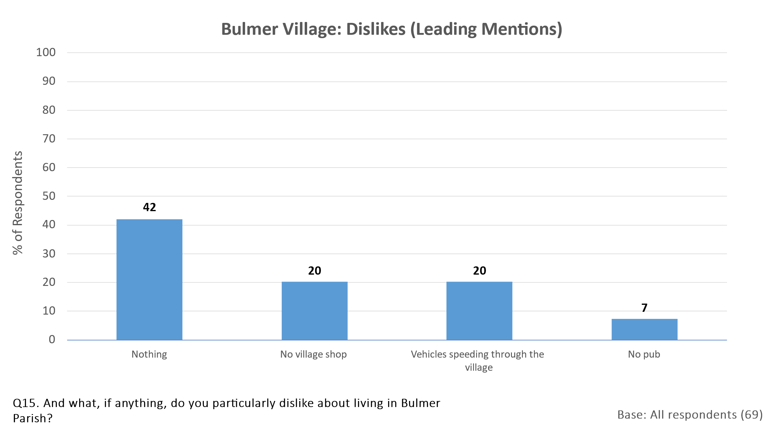

**4.3.2 Prompted Ratings of Aspects of living in Bulmer Parish**

Respondents were next presented with a prompted list of aspects of living in the Parish and asked to rate each on a scale from ‘very good’ to ‘very poor’. Again, it was very clear how satisfied the great majority of residents are with their choice of location. At least three quarters of respondents rated as ‘very good’ the attractiveness of the local countryside (96% rated it ‘very good’), the amount of green space (86%), the size of the village (80%), the wildlife (77%) and the availability of local walks (75%).

Many respondents did not feel able to comment on the access to schools, the church activities or the facilities for children. However, the 15 respondents with children in the household mostly rated access to schools as good (53% rated access as very good, 27% as quite good, only 13% as quite poor and 7% had no opinion).

Most of those who did not rate an aspect as ‘very good’ rated it as ‘quite good’ and the only aspects attracting significant ratings of ‘quite poor’ or ‘very poor’ were the facilities for children and those for adults. Of the 15 respondents with children in the household, only 7% rated the facilities for children as ‘very good’ and 27% as ‘quite good’, but 33% rated them as ‘quite poor’ and another 33% as ‘very poor’. If the Parish is hoping to attract more families with children into the area, facilities would seem to be in need of improvement. 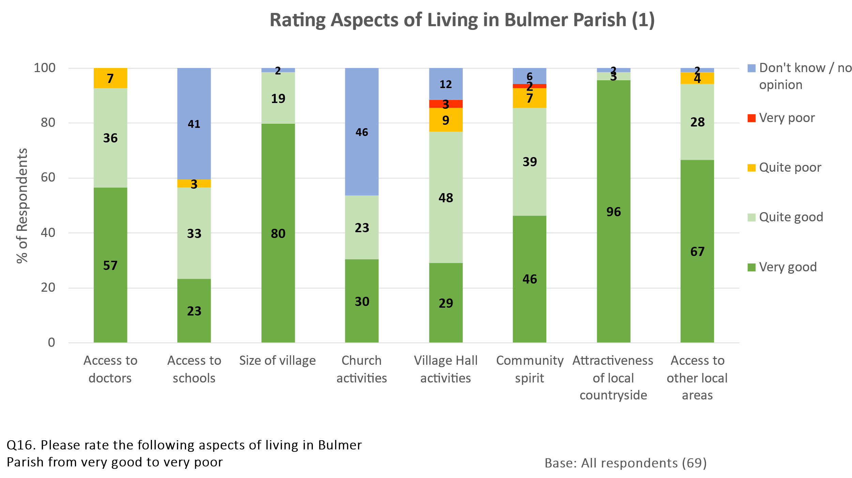

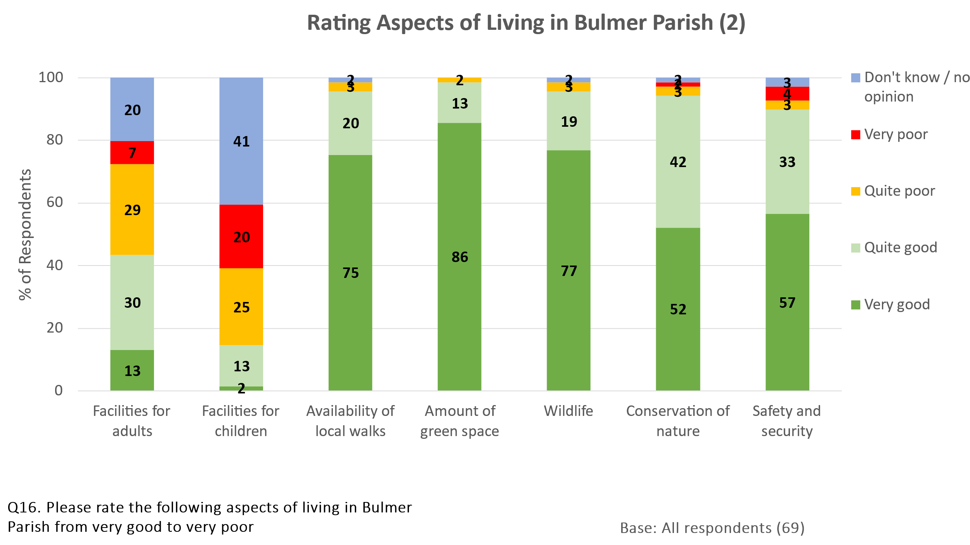

**4.3.3 Desired Changes, Additions or Improvements to the Facilities**

**4.3.3.1 Spontaneous Comments**

When respondents were asked what changes, additions or improvements they would like to see to the facilities in the village, 28% answered that nothing was required.

A village shop would be welcomed by 16% of respondents and a Post Office by a further 6% (the lack of a shop had earlier been mentioned as one of the few dislikes about living in the Parish). 15% requested more events or activities in the Village Hall. Speeding traffic had also been mentioned as one of the dislikes of living in the Parish and this was reflected in a request by 9% of respondents for speed limits to be enforced. Other desired changes expressed by a minority were for a park / playing field or anything to encourage young families to live in the Parish.

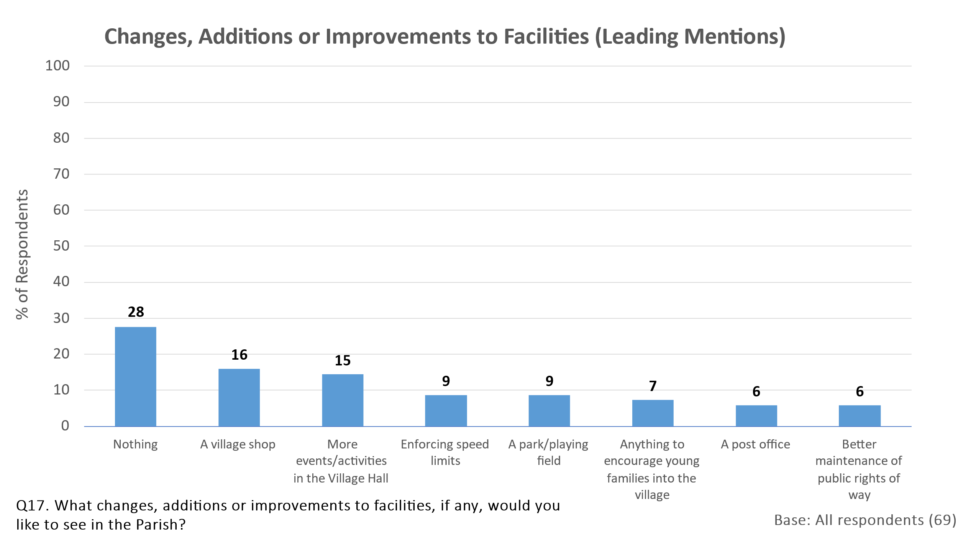

**4.3.3.2 Prompted Reactions**

Respondents were next prompted with a list of possible changes, additions or improvements and asked which they would see as a ‘priority item’, which would be ‘desirable but not essential’ and which would be ‘not important’. Results are shown in the chart below.

The items most likely to be seen as a priority were Speed Control Measures (rated a priority item by 51% of respondents), improved mobile phone connection (42%), maintenance and signage of footpaths (38%) and reduction in dog fouling (35%). Respondents aged 65 or over were particularly likely to regard speed control measures as a priority item (63% did so).

The items most likely to be seen as ‘not important’ were more available housing (55% rated this as ‘not important’), allotment / community orchard (46%) and community green space (38%). It should be noted, however, that, with the exception of more available housing, more respondents rated these items as ‘desirable’ or a ‘priority’ than as ‘not important’.

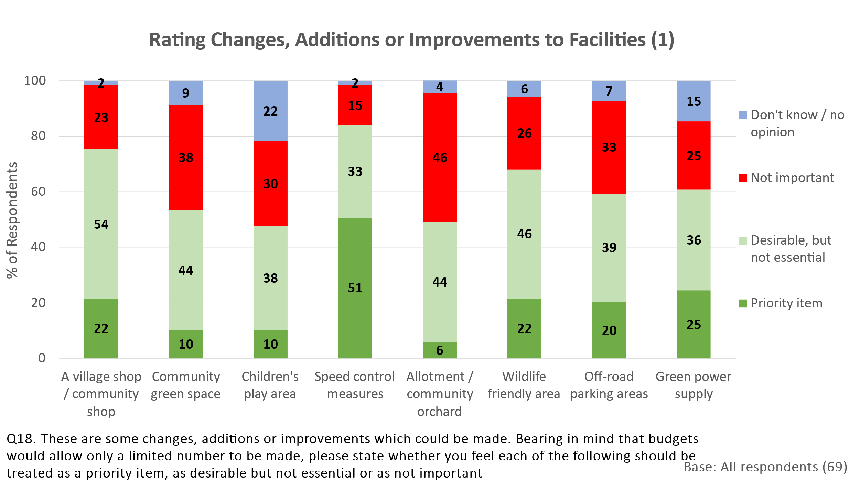

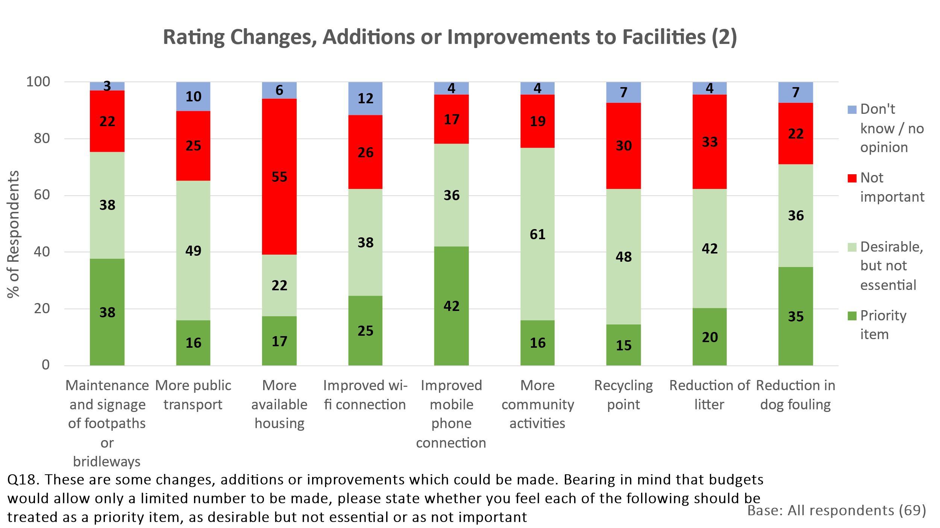

**4.4 Attitude to Housing Development in the Parish**

**4.4.1 Desired Level of Housing Development**

The next section of the questionnaire asked respondents about their preference for different levels of housing development in the Parish within the next 20 years.

No respondent preferred more than a maximum of 20 additional houses. Indeed, a quarter (26%) preferred no additional houses at all and 77% wanted none or no more than 10.

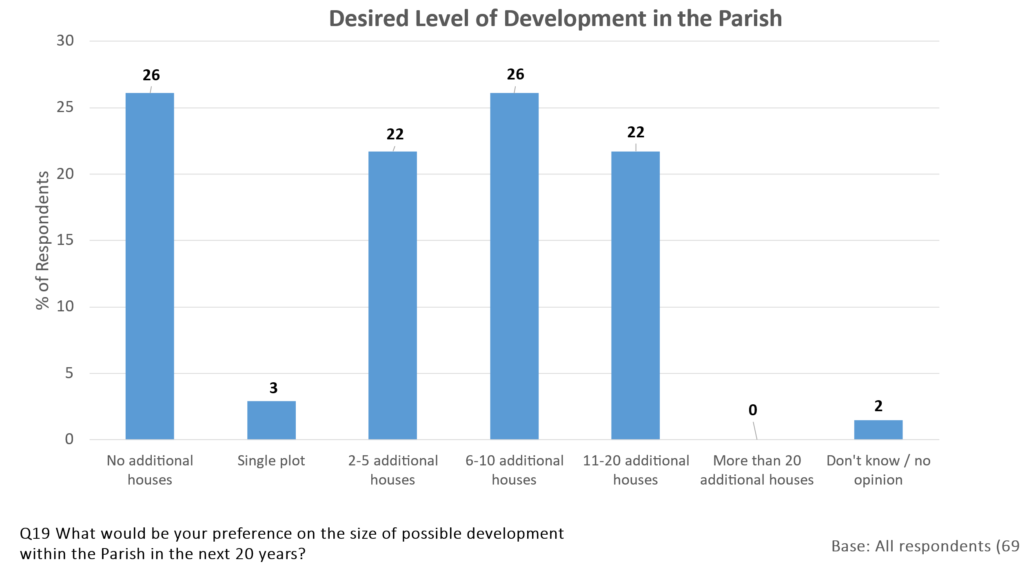

Perhaps surprisingly, older respondents aged 65 or over were slightly more inclined to accept development than younger respondents, though the small sample sizes for these age breaks should be noted.

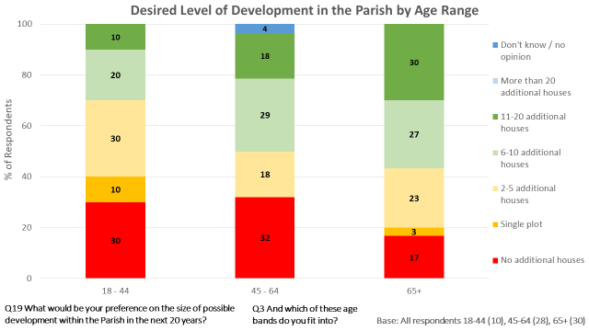

**4.4.2 Type of Home Appropriate for any Development in the Parish**

Those willing to consider at least some housing development in the Parish were asked what type of home they felt would be appropriate. They were allowed to choose more than one option if they wished and many respondents did so.

The chart below shows that over two thirds of these respondents would see either two- bedroom starter homes or three-bedroom family homes as appropriate. Single storey homes or bungalows would be seen as appropriate by almost half of these respondents.

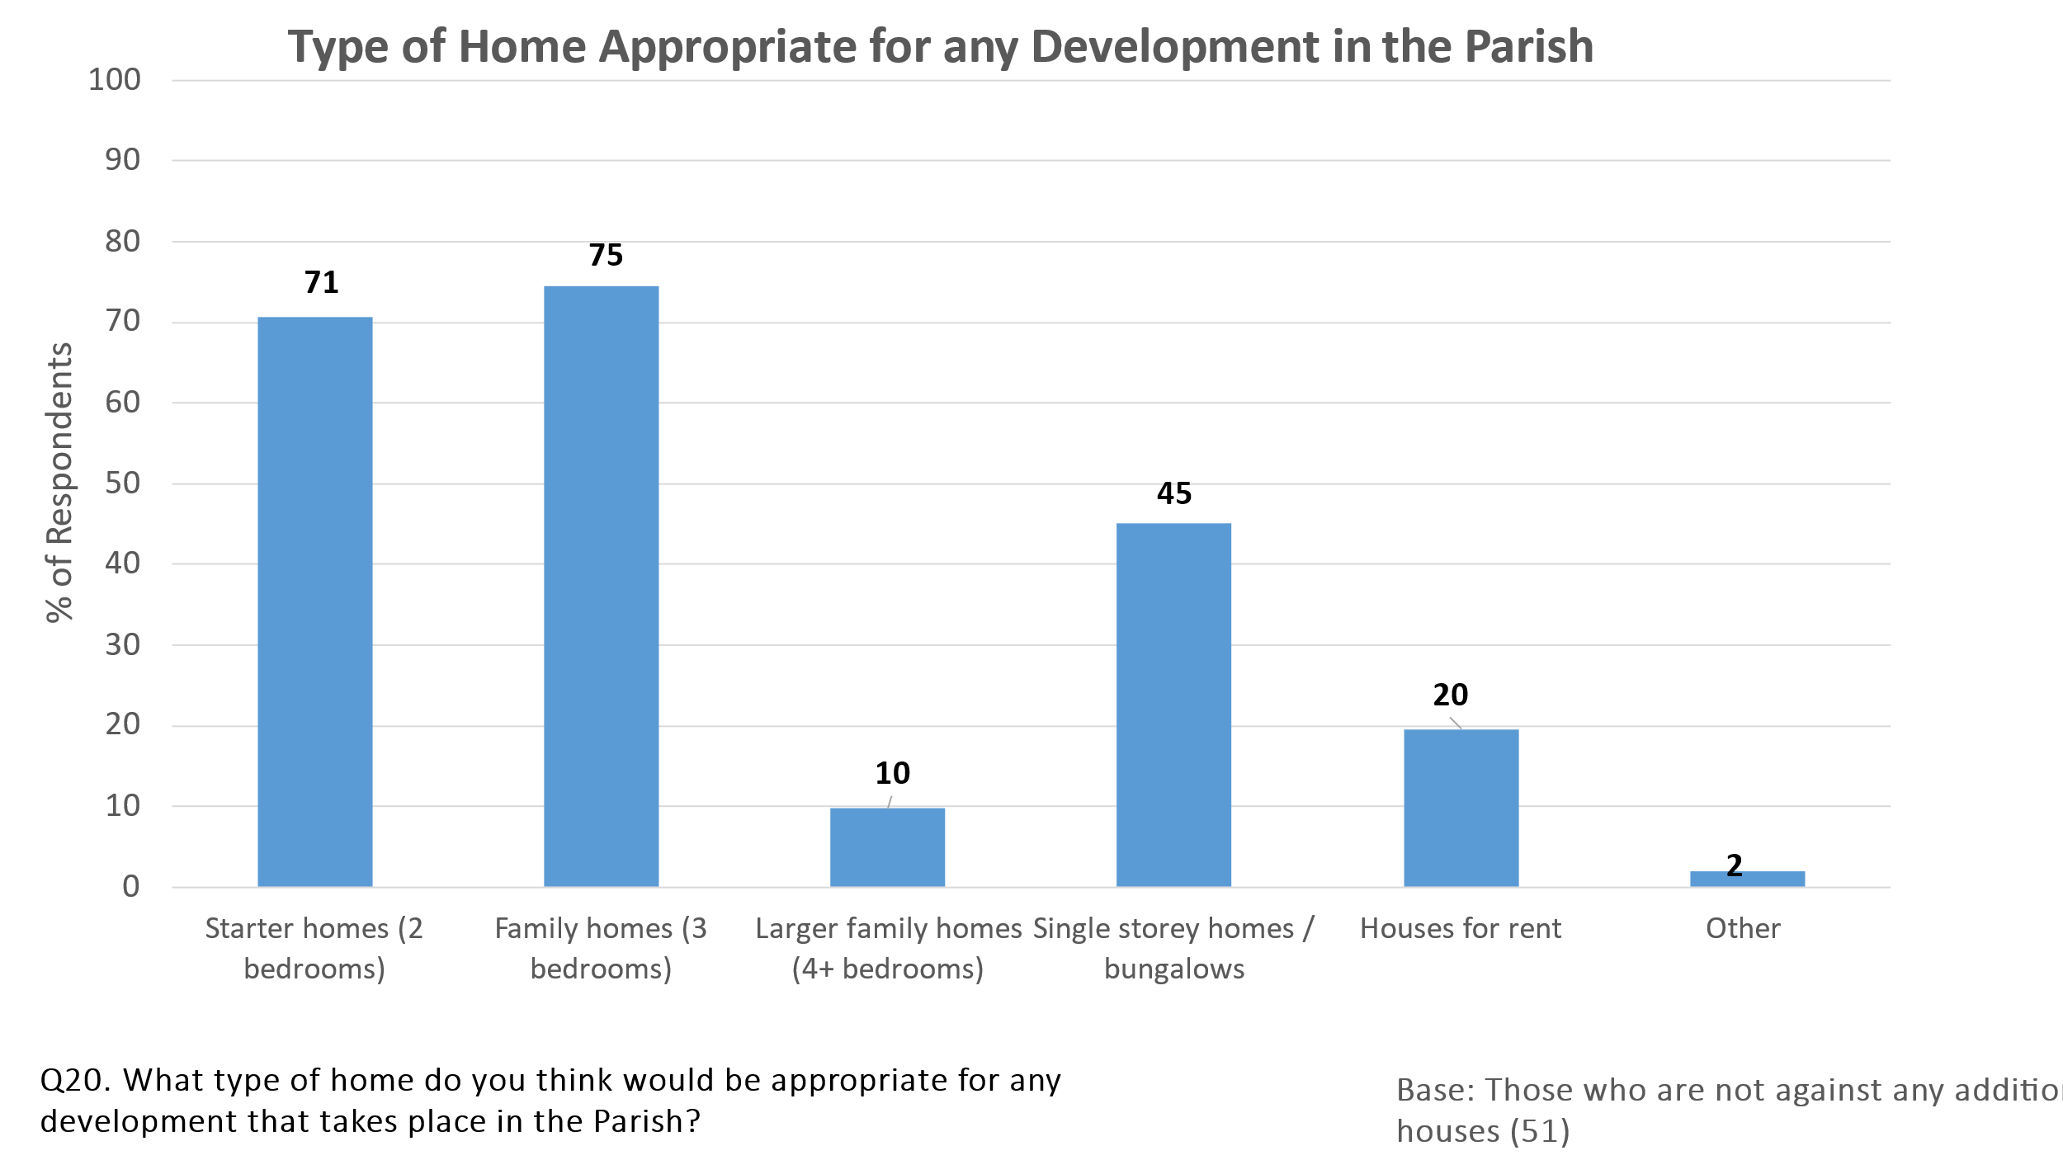

**4.4.3 Style of Home Appropriate for any Development in the Parish**

Respondents willing to consider some level of development in the Parish were next asked what style of home they thought would be appropriate. There was almost universal rejection of new homes not conforming to the style of the conservation area, but either conservation of existing buildings or new builds conforming to the style of the conservation would be approved by the great majority.

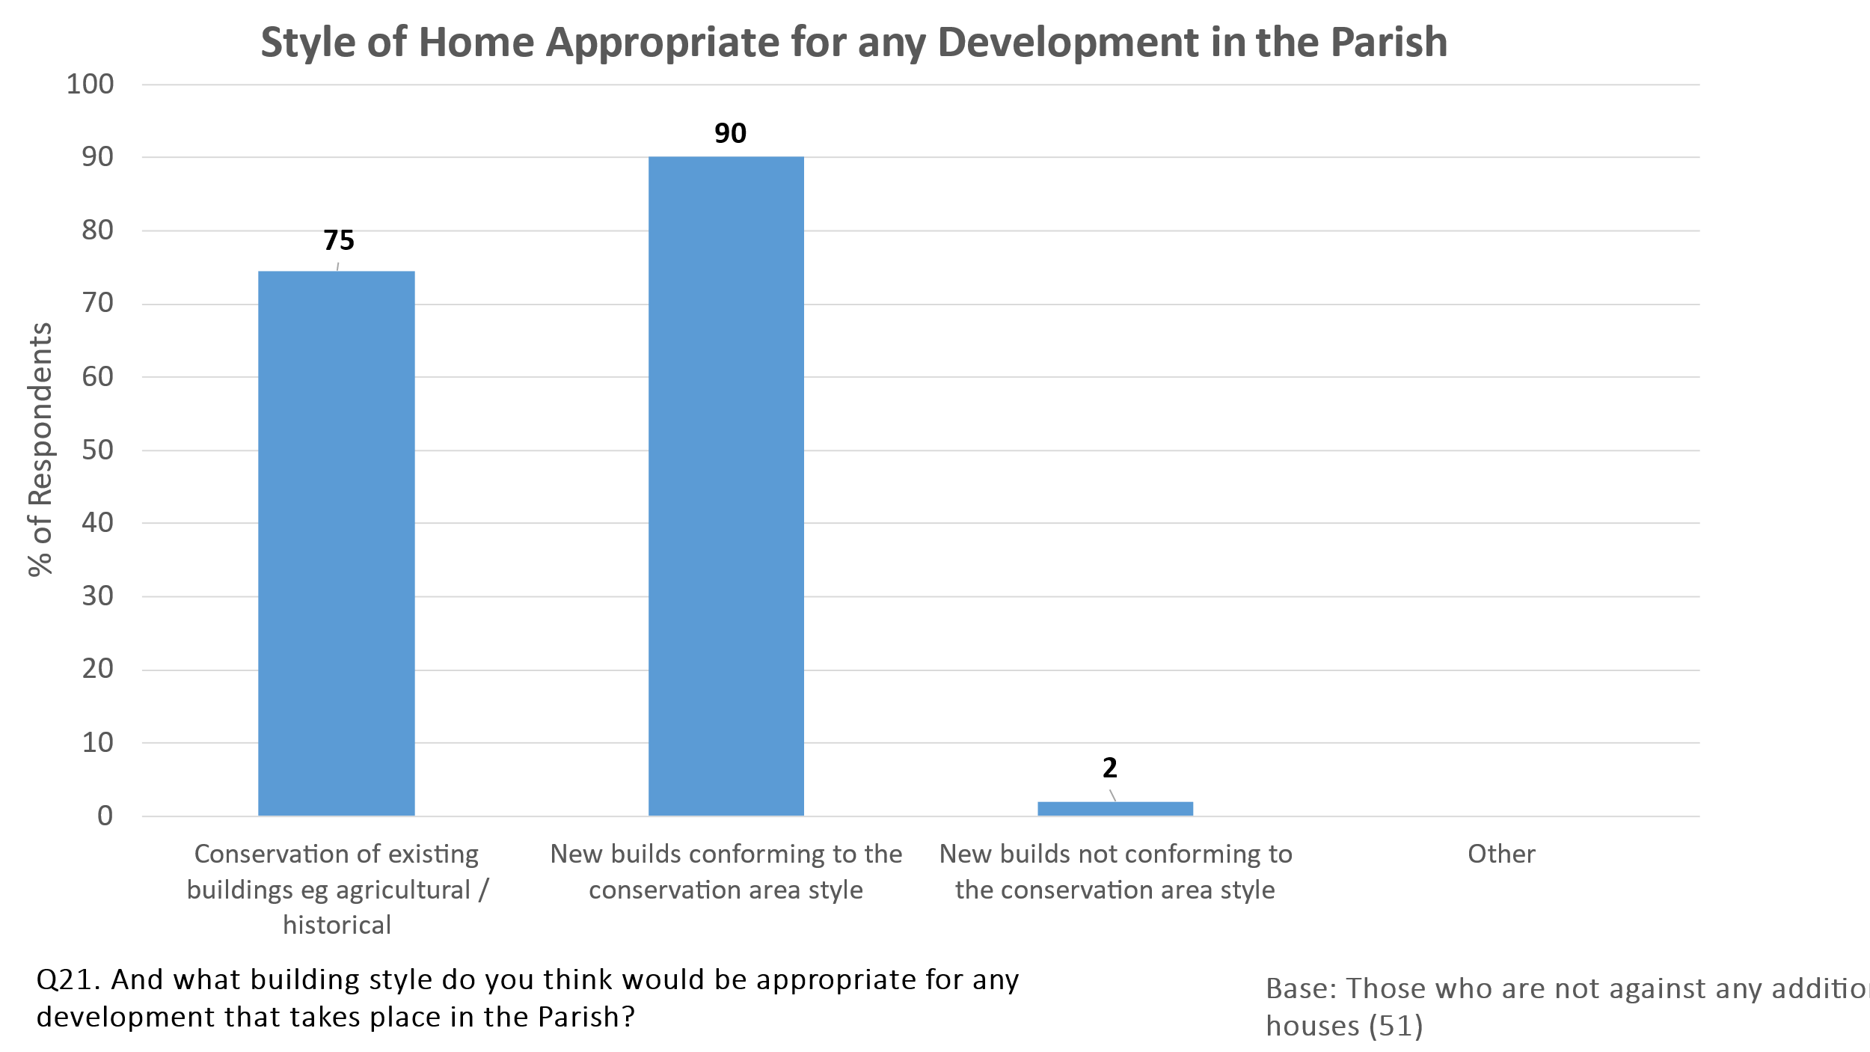

**4.4.4 Desired Location for any Development in the Parish**

Those willing to consider some level of development in the Parish would favour it being sited as in-fill development where the opportunity allowed (73% favoured this option) or on the eastern edge of the village (53%). Development on the western edge or elsewhere was less favoured.

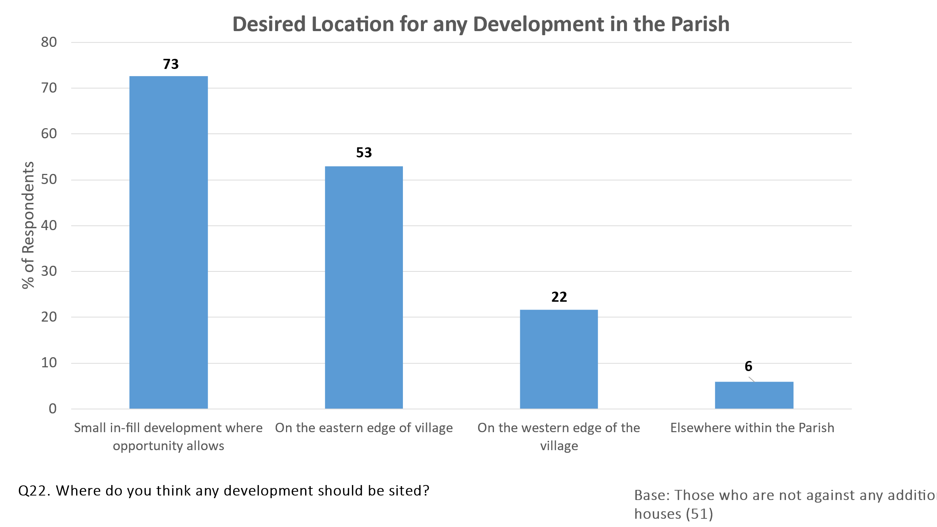

Preferences for the location of any development differed by gender. Females were more inclined to favour in-fill development, whereas males preferred development on the eastern edge.

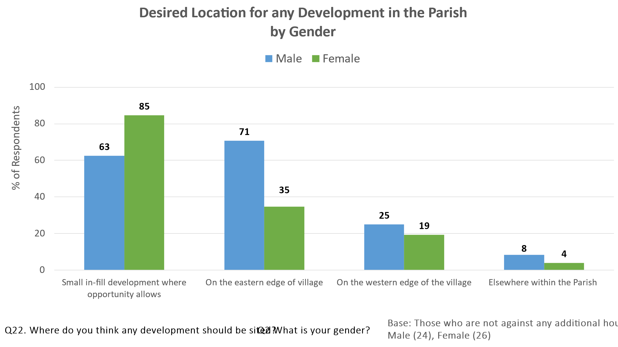

**4.4.5 Importance of Features if Housing Development were to take Place**

## All respondents (irrespective of whether or not they had indicated willingness to see any housing development in the Parish) were asked for their views on the importance of features if development were to take place. The two charts below summarise the views at total sample level.

## Many of the features were seen as ‘very important’. Around three quarters or more of all respondents rated as ‘very important’ sustainable drainage systems (84%), appropriate design / architecture (78%), adequate off-street parking (75%) and adequate access (e.g. no parking on sharp corners or narrow lanes) (74%). No more than 3% of respondents saw any of these four features as ‘not very’ or ‘not at all’ important.

## Other features rated ‘quite’ or ‘very’ important by at least 60% of all respondents were incorporated gardens for each new dwelling (90%), green energy (74%), and better Broadband (61%). 67% of respondents with children in the household rated play areas for children as ‘very’ or ‘quite’ important compared with 39% of those without children in the household.

Features seen as ‘not very’ or ‘not at all’ important by the majority of respondents were Commercial Development (78% felt ‘not very’ or ‘not at all’ important), Leisure Facilities (66%) and Allotments (64%).

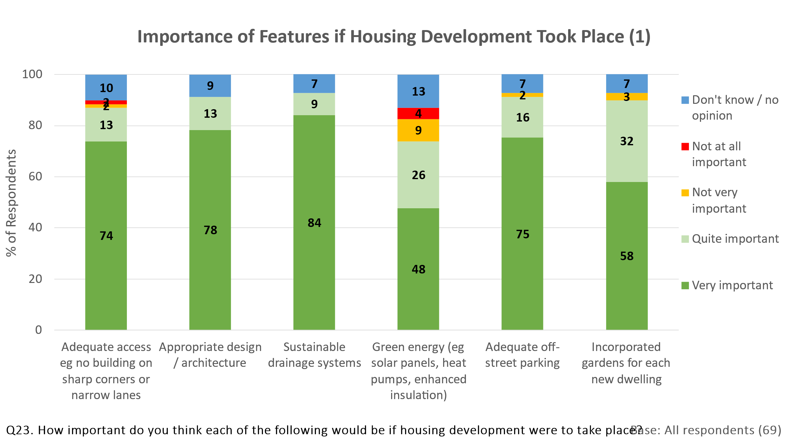

## 

## 4.4.6 Perceived Benefits and Concerns towards future Development

**4.4.6.1 Spontaneous Comments**

All respondents were asked for their spontaneous thoughts on the benefits future development would bring to the Parish and for any concerns they might have.

Over two fifths of respondents (41%) felt that there would be no benefits at all. This ranged from 100% of those preferring no development at all to 29% of those preferring 1-5 additional houses and even 15% of those preferring 16-20 additional houses. The two benefits most likely to be mentioned (but by only around one fifth of all respondents) were that it would bring children to the village through affordable family homes and that it would broaden the spread of ages within the village.

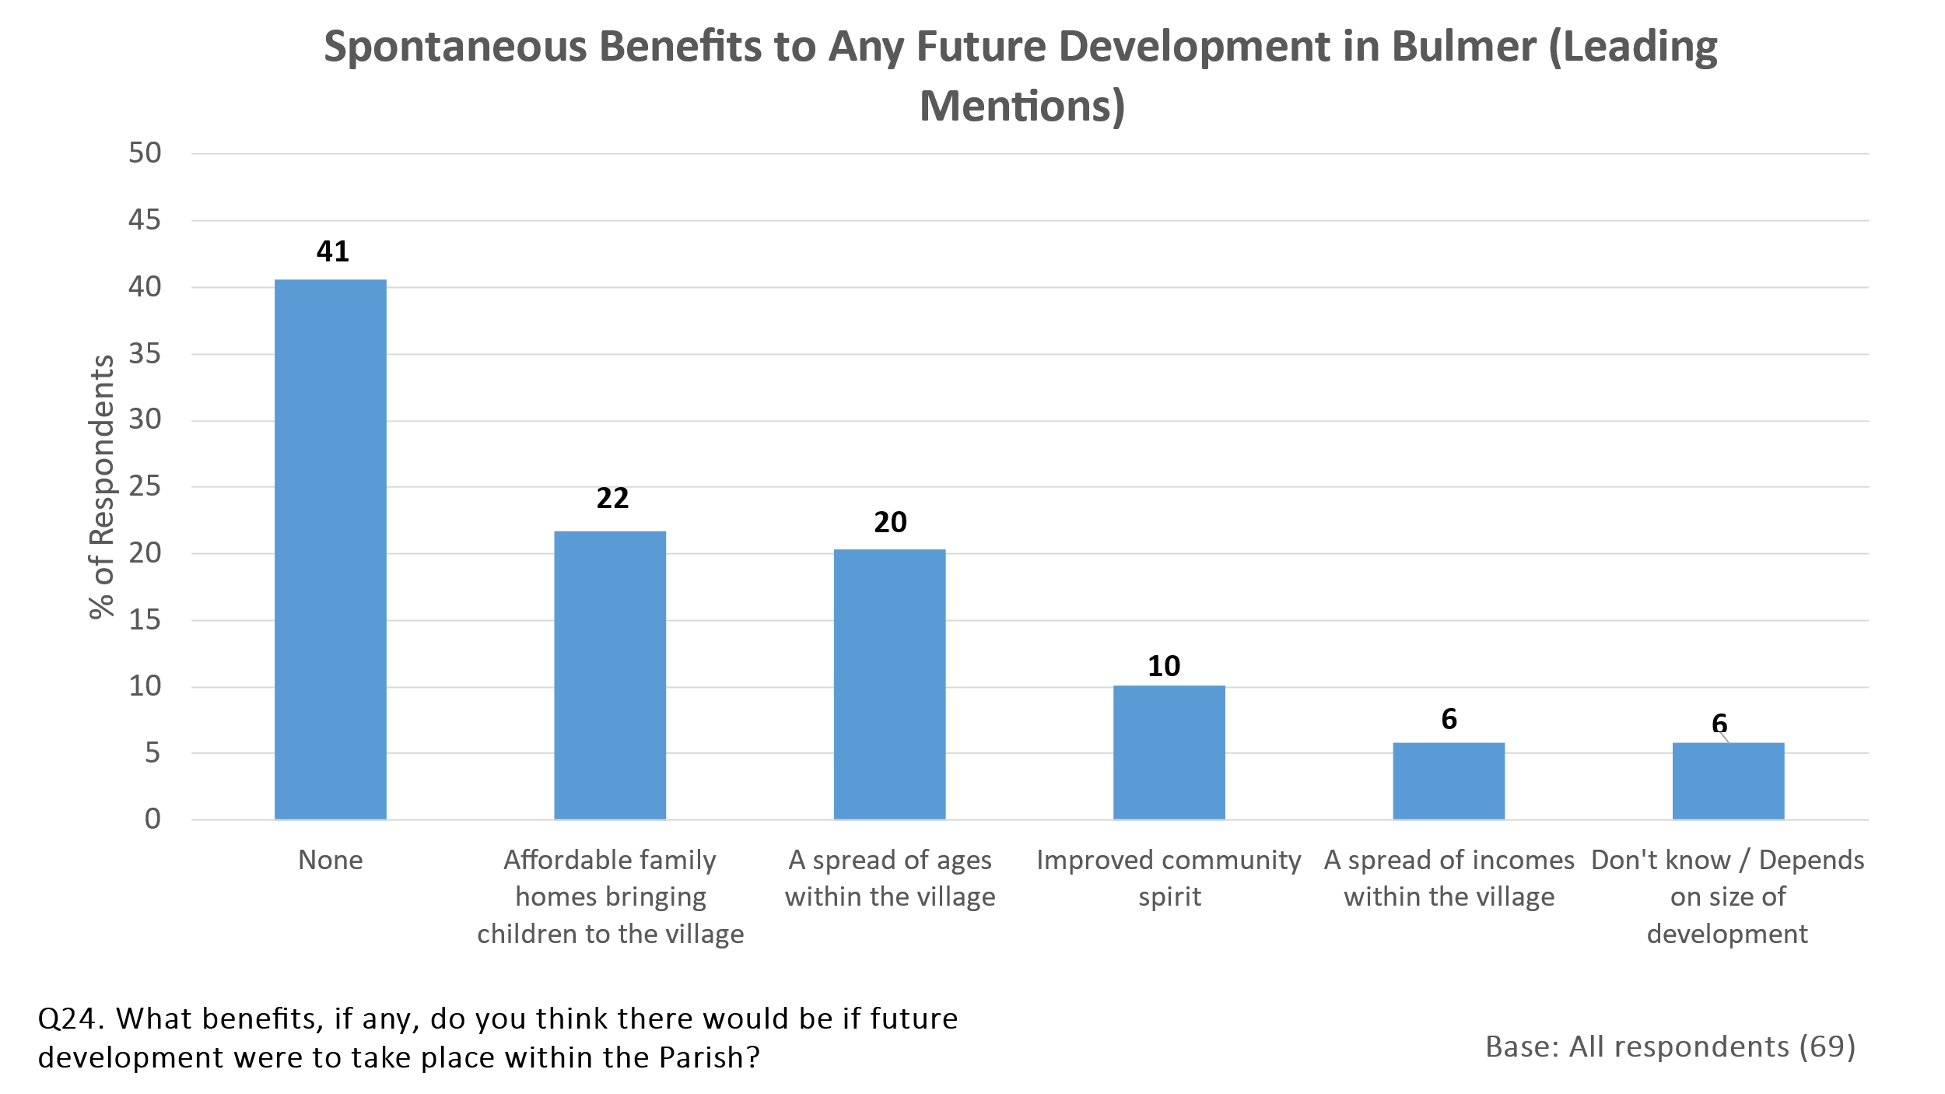

The main concerns expressed spontaneously were that development would bring increased traffic, that it would change the character of the village and that the current infrastructure could not cope with the expansion. The concern about an increase in traffic was particularly strong amongst those wishing no additional housing or no more than 5 additional houses (54% of these respondents mentioned it as a concern compared with only 15% of those preferring 6-20 additional houses).

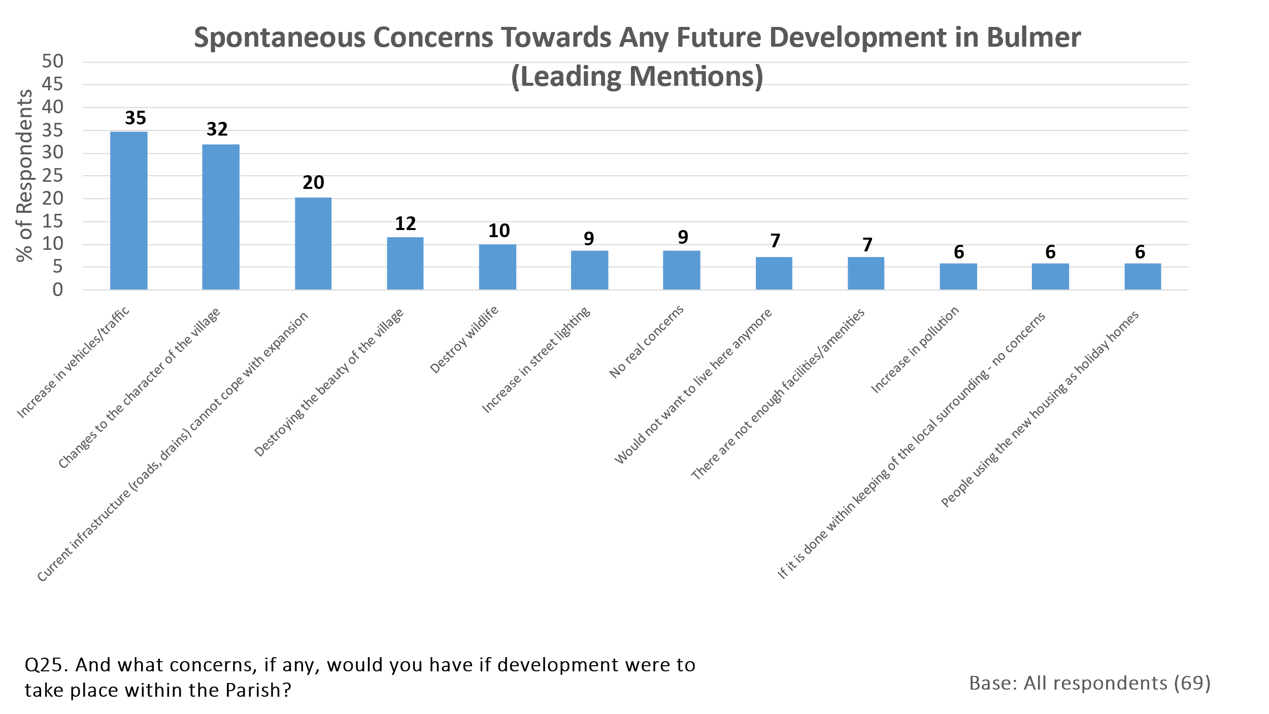

**4.4.6.2 Prompted Concerns**

Respondents were next prompted with a list of concerns “which some people have expressed” and asked which they saw as a major concern, which as a minor concern, which as not of concern at all and which depended on the scale of the development. It was stressed that other people did not see some of the issues as a problem, so as not to lead the respondents too much.

As the chart below confirms, respondents expressed major concerns in many respects. Indeed, more than half of all respondents expressed major concern with all but one of the nine prompted statements. Aspects of greatest concern were excessive parking on roads (75% saw this as of major concern), loss of character, appearance or feel (74%) and speeding vehicles (70%). Even the statement to which less than half the respondents expressed major concern (pressure on local footpaths / bridleways) was of minor or major concern to 71%. 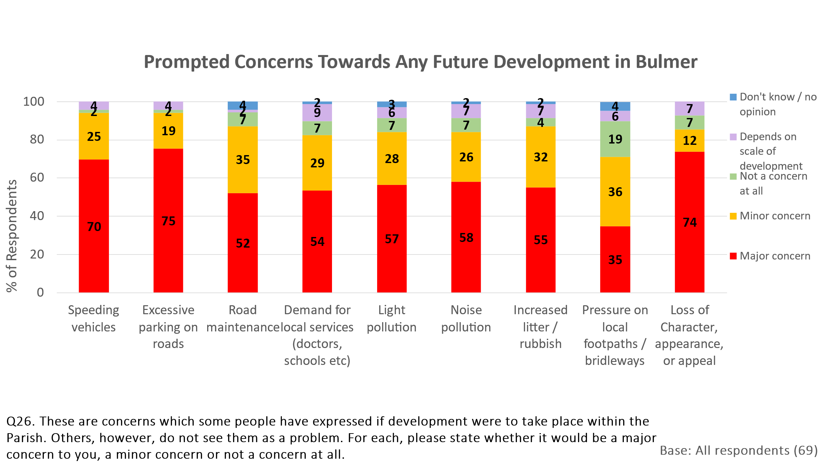

Many of these concerns were shared even by those preferring development of 6-20 additional houses. For example, 64% of these respondents expressed major concern about excessive parking, 55% about loss of character, appearance or appeal and 48% about speeding vehicles. It is clear, therefore, that even those willing to consider some development would need much reassurance that their concerns would be addressed.

**4.5 Barriers to living in Bulmer Parish**

29% of respondents claimed to know someone who would like to live in the Parish. This is equivalent to at least 20 people known to a respondent. It is possible that there may have been some double counting as a few of these people may have been in the mind of more than one respondent (particularly those living in the same household) but there would still appear to be quite significant unfulfilled demand.

Reasons why respondents felt that these people were unable to live in the Parish mostly centred on high house prices / rental costs or the lack of Affordable Housing. A definition of Affordable Housing was provided as “social rented, affordable rented and intermediate housing, provided to eligible households whose needs are not met by the market”.

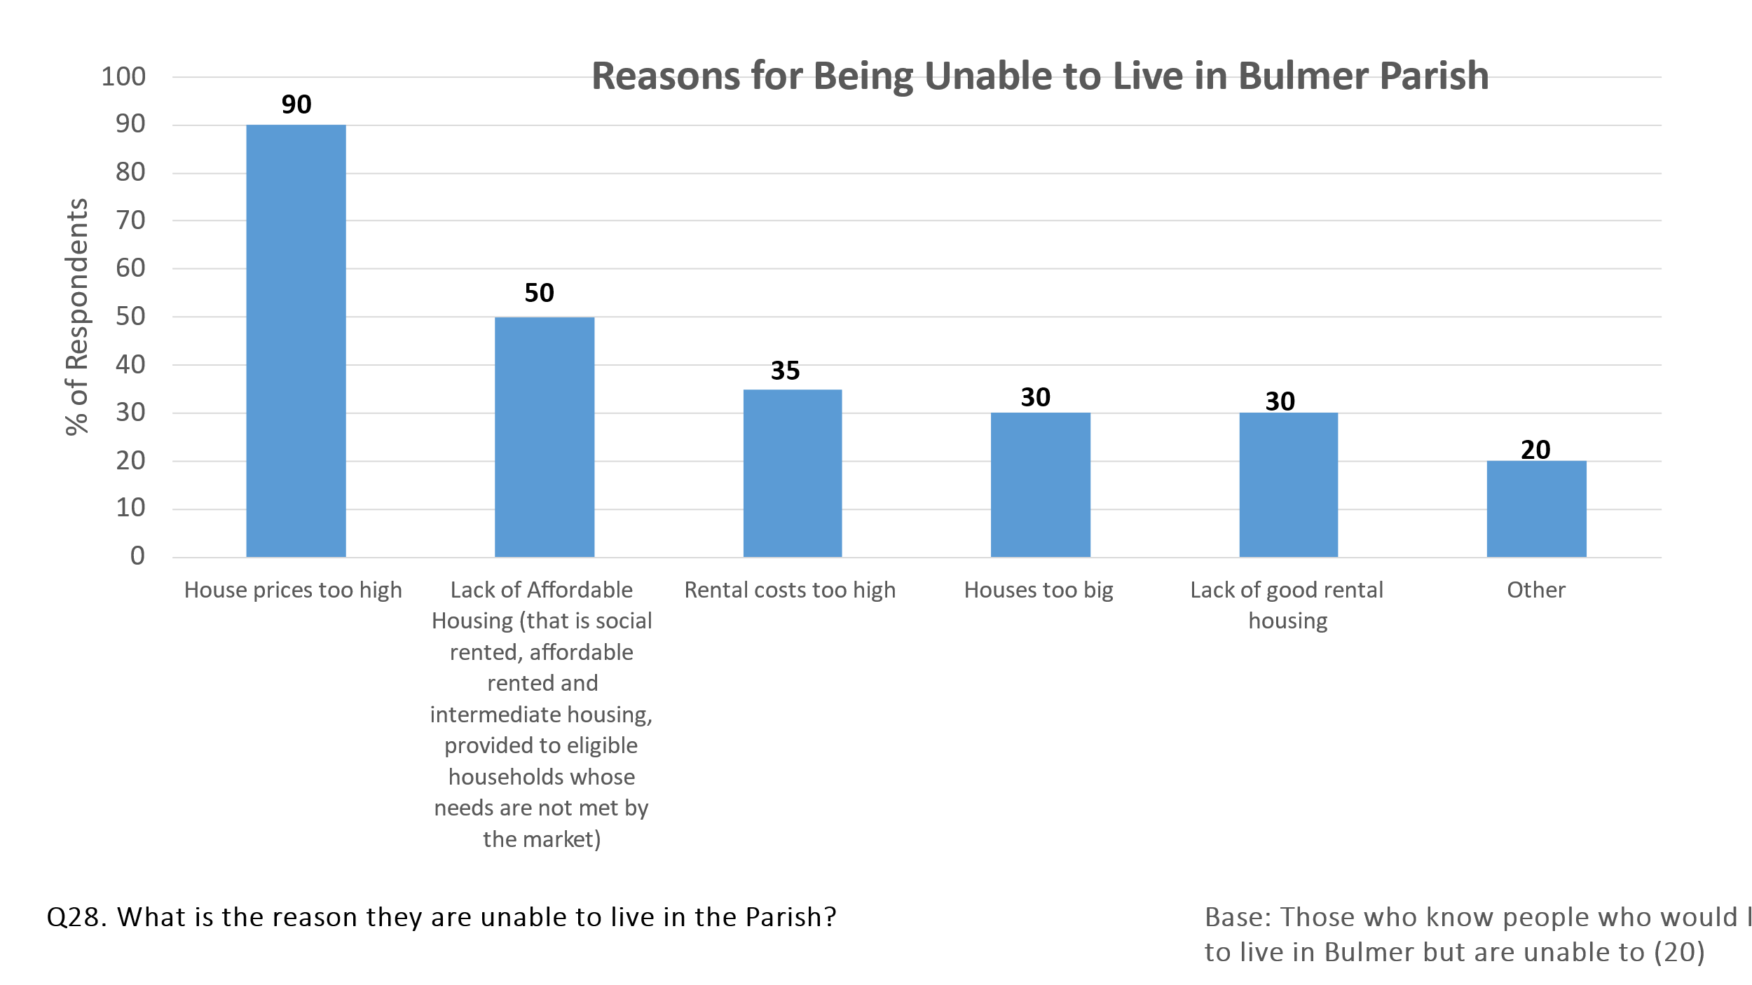

**4.6 Views on Affordable Housing**

Respondents were asked how strongly they agreed or disagreed that the Parish's Neighbourhood Plan should allocate sites for Affordable Housing to meet local need.

Whilst almost two thirds of all respondents agreed ‘slightly’ or ‘strongly’ that the Plan should allocate some sites in this way, 26% strongly disagreed. As might be expected, most of those disagreeing were the respondents wishing there to be no development in the Parish. 72% of this group strongly disagreed with the statement.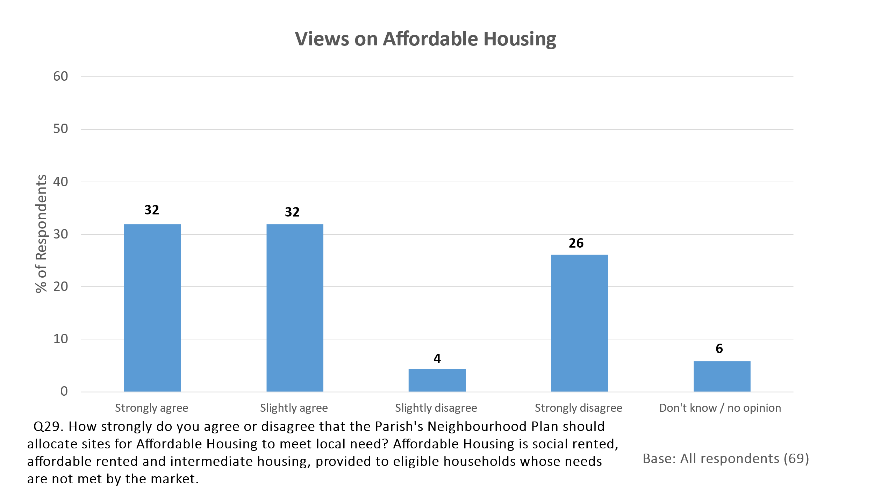

**4.7 Tenants’ Desire to Buy a House in Bulmer**

20 of the 69 respondents completing the survey were renting a property. 12 of these tenants stated that they would like to buy a house in the Parish. All these 12 tenants stated that the high prices of houses in Bulmer Parish were preventing them from doing so.

**4.8 Sources of Community News and Information**

Respondents were asked to rate the usefulness of different sources of community news and information to them.

The village newsletter and word of mouth / grapevine were both rated as ‘very useful’ by over 50% of those completing the survey and as ‘quite’ or ‘very’ useful by over 85%. Parish noticeboards were seen as ‘quite’ or ‘very’ useful by 87% of respondents and the Parish website and local newspapers by around half the respondents. Facebook, Twitter / X and local radio were less likely to be seen as useful, partly because many respondents felt unable to express an opinion about them.

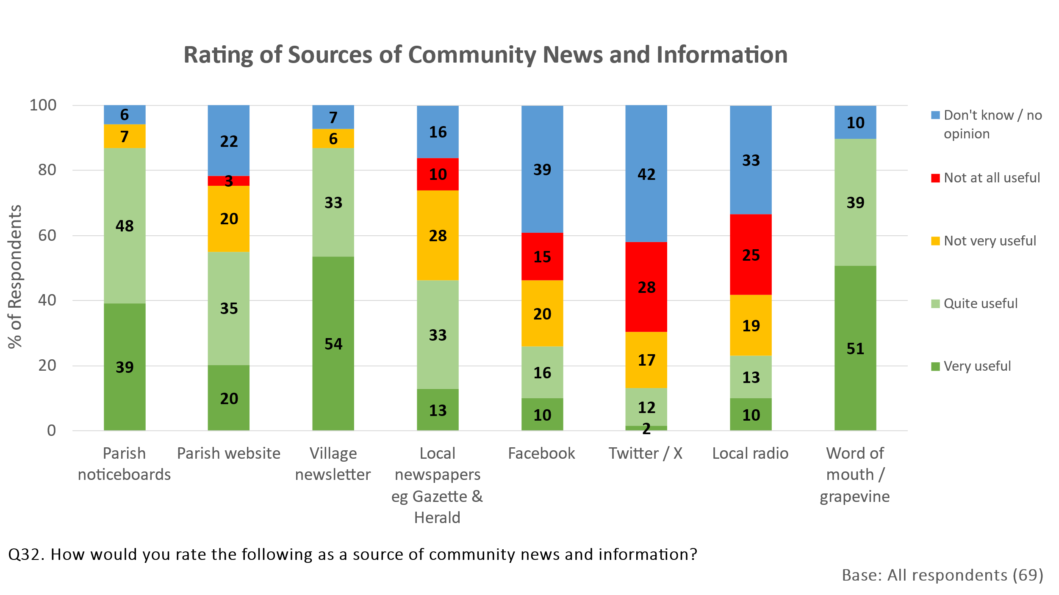

Sources used to find out about events, activities and developments in Bulmer Parish other than those listed above included door leaflet drops (16% used this source), The Howardian (14%), the Bulmer Village What’s App Group (13%) and email (1%).

**4.9 Importance of Features to the Character of Bulmer Parish**

An overwhelming majority of respondents felt that all the stated features shown on the chart below were ‘very important’ to the character of Bulmer Parish. Virtually all those who did not feel the feature was ‘very important’ felt it was ‘quite important’.

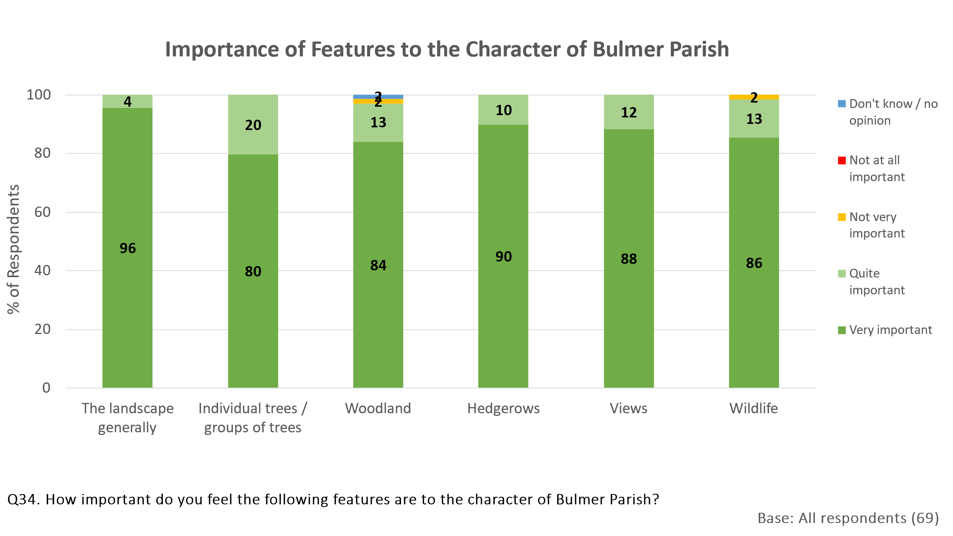

**4.10 Final Comments**

As a final question, respondents were asked whether they would like to raise any other points which had not been mentioned and which they thought should be included in the Neighbourhood Plan.

Over half of the respondents (52%) made no further comments or felt that everything had been covered. Most of those that did comment tended to re-iterate or elaborate upon their earlier comments about housing development (10%), the importance of maintaining the beauty and character of the Parish (7%), speeding issues / the need for traffic calming (4%) or Affordable Housing (3%). No specific suggestions for issues not already raised in the questionnaire were made by more than one respondent.

We suggest that the Plan can therefore be developed on the basis of the issues raised in the questionnaire.

A full list of all verbatim comments provided in answer to this final question can be made available if required.